

**School of Computer Science**

**COMP 8547 Advanced Computing Concepts – Fall 2023**

**University of Windsor**

**Final Project Report**

**Group 6 - Null Pointers**

**Section - 3**

**Variant: Co-op Job Finder**



**Team Members**

| **Student Name** | **Student ID** |
| --- | --- |
| Apoorv Shamma | 110125728 |
| Kishan Modi | 110131833 |
| Meet Patel | 110126852 |
| Miti Tamakuvala | 110126404 |
| Vikram Singh Bedi | 110125886 |

Submitted to: Dr. Olena Syrotkina

Date: December 5th, 2023

**Variant: Co-op Job Finder (Existing Variant - Top Paid Job Analysis)**

The idea of the project was to find co-op job openings from 3 websites Linkedin, Indeed, and Workopolis. We have made a search engine in which users can search co-op job postings by keywords like Software Engineering Co-op, and Marketing Co-op

We have implemented a Search Engine using the following features:

**Features Implemented:**

# 1. Crawler

**Developed by:** Vikram Singh Bedi

**Libraries/Data Structure/Algorithm Used**: Selenium, Array

**Files**: LinkedinCrawler.java, WorkopolisCrawler.java, IndeedCrawler.java

**Explanation**:

A web crawler is a program that systematically browses the World Wide Web and gathers information from websites. The primary purpose of a web crawler is to index the content of websites, allowing search engines to retrieve and present relevant results to users when they enter queries.

In our scenario, the Web Crawler navigates three websites: Linkedin, Indeed, and Workopolis. It initiates the process from the respective home pages, providing input for the job title ("co-op") and job location ("Canada"). Subsequently, it reviews the search results, which comprise job postings relevant to our search criteria. The crawler extracts the URL for each posting, visits each URL, and downloads the HTML content for further processing by the Web Parser.

**Exception Handling:**

1. In case the crawler encounters an exception while extracting job links for any job posting we use try-catch to handle the exception and keep crawling instead of exception stopping the entire code flow

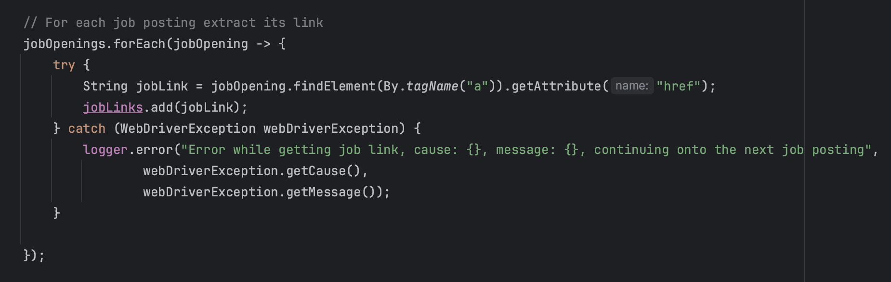

1. Sometimes on Indeed, there comes a pop-up asking the user to log in, we have used try-catch to handle that, it tries to fetch the pop-up and close it, and in case it is not present selenium throws NoSuchElementException, we have handled that exception to simply log the exception that no pop-up was present

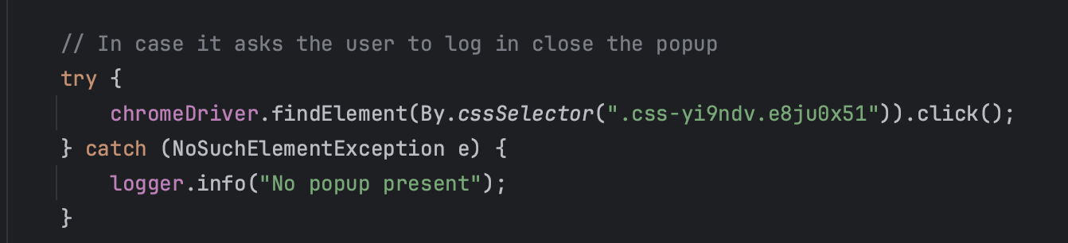

1. In case due to a change in the structure of the web page one of the crawlers stops working due to some reason and throws an exception we have surrounded the code with a try-catch where we catch the WebDriverException which is a superclass of all exceptions thrown by Selenium. We simply log the error in that case, and proceed to crawl other websites instead of stopping the server due to the exception

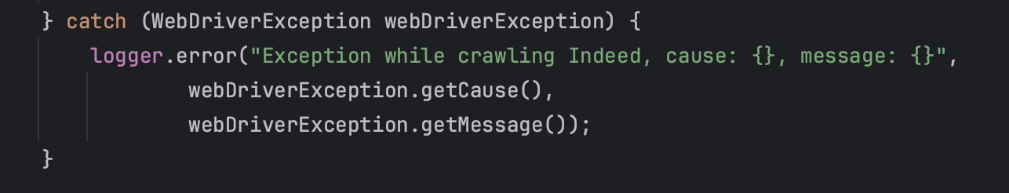

**Linkedin Crawler:**

The Linkedin Crawler is in the **LinkedinCrawler.java** file

The LinkedIn Crawler has the function **getJobPosting** which takes jobTitle and location and input. We have provided **co-op** as the jobTitle and location as **Canada**

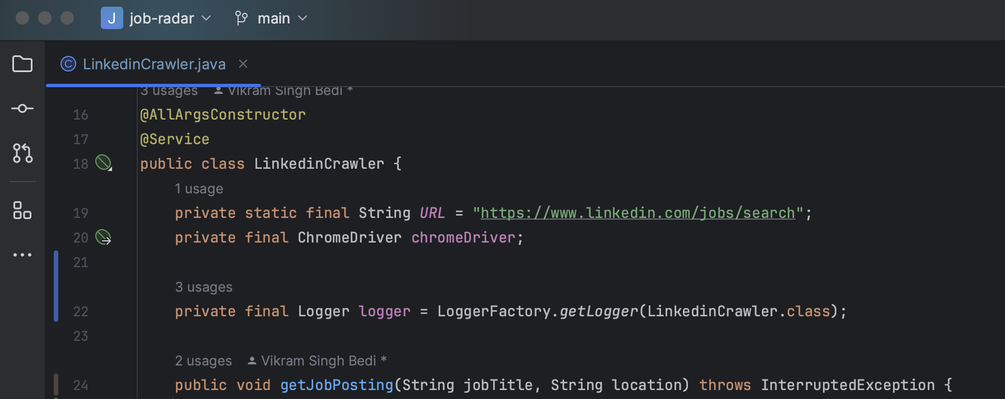

The web crawler first goes to the LinkedIn URL using the **get()** function where we can search for jobs on Linkedin

**Code**:

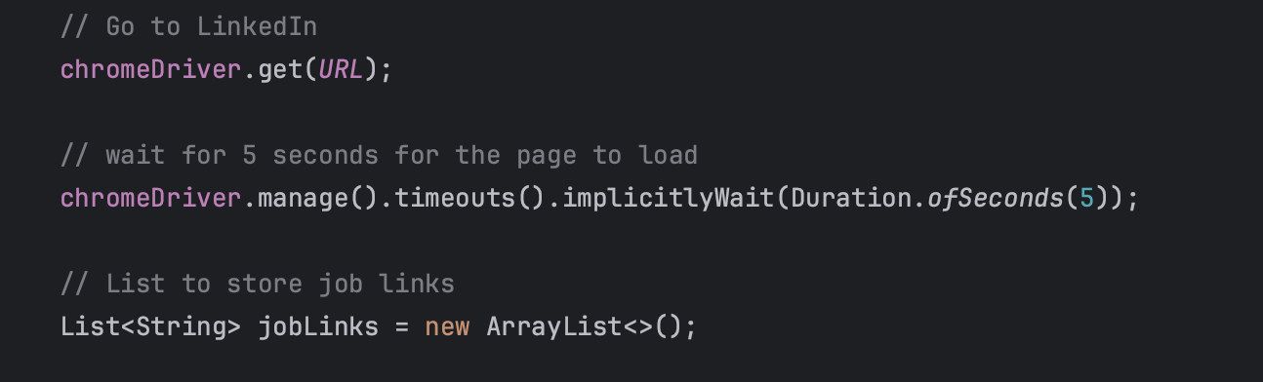

**Output**:



The crawler finds both the input boxes for job title and job location using the **findElement()** method. It then uses the **sendKeys()** method of selenium to provide input for both the input boxes and then uses **click()** to press the search bar which results in job postings with our given keywords ie. **co-op** and **Canada.**

**Code**:

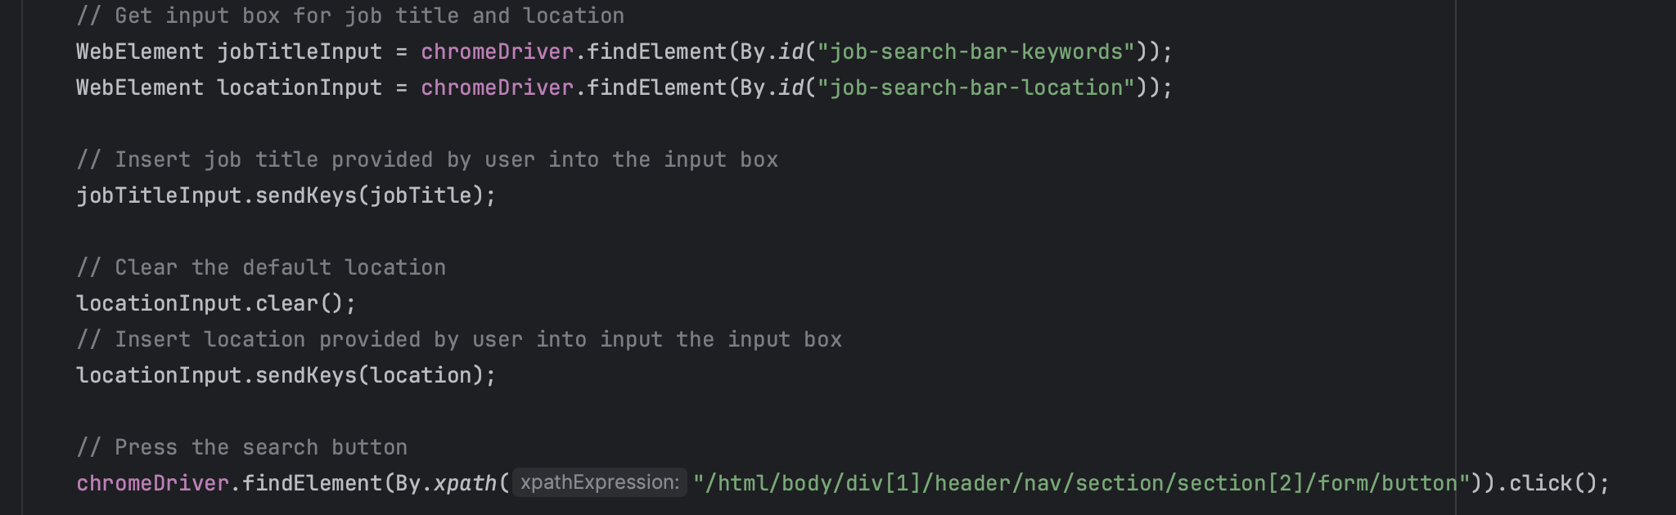

**Output**:



Then we scroll to the bottom using **js.executeScript("window.scrollBy(0,5000)");**

After scrolling down we press the “**See more jobs**” button to load more jobs onto the screen. We repeat this 5 times to load more jobs.

**Code**:

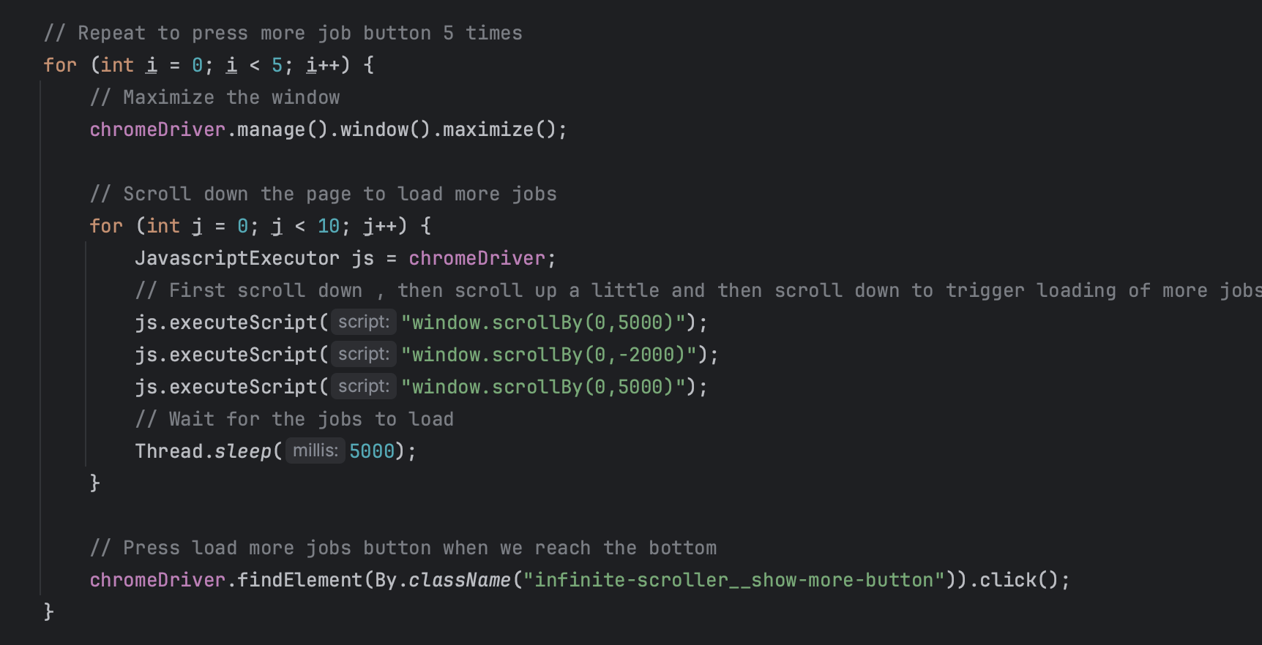

**Output**:



After that for each job posting, we extract its job link from the job posting div tag and add all these links into a list which will be a list of URLs for each of the job posting

**Code**:

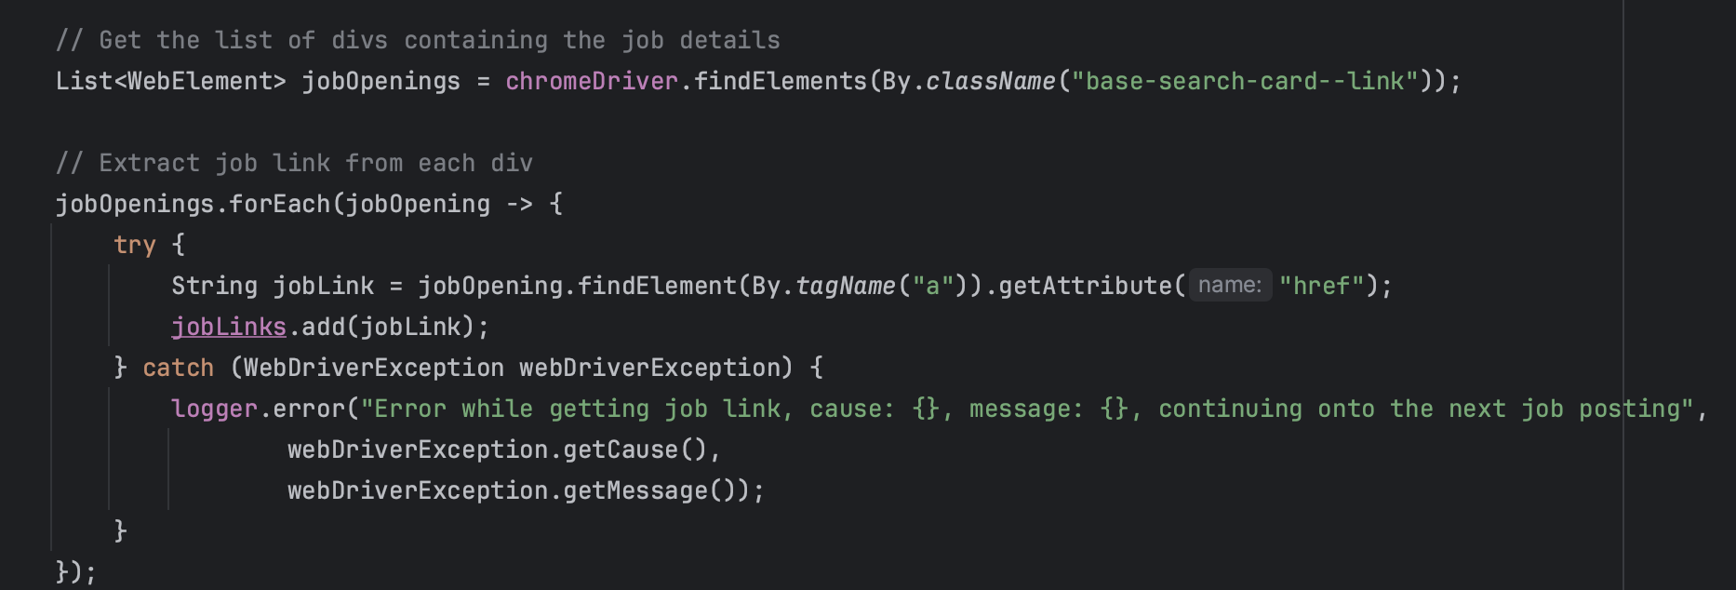

**Output**:

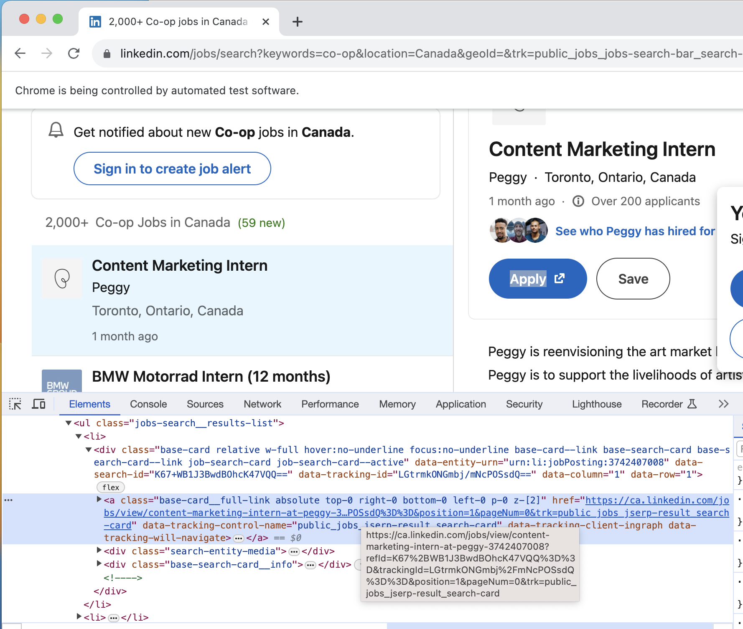

Then we traverse the list of job URLs open each job posting and download the HTML page onto the system.

**Code**:

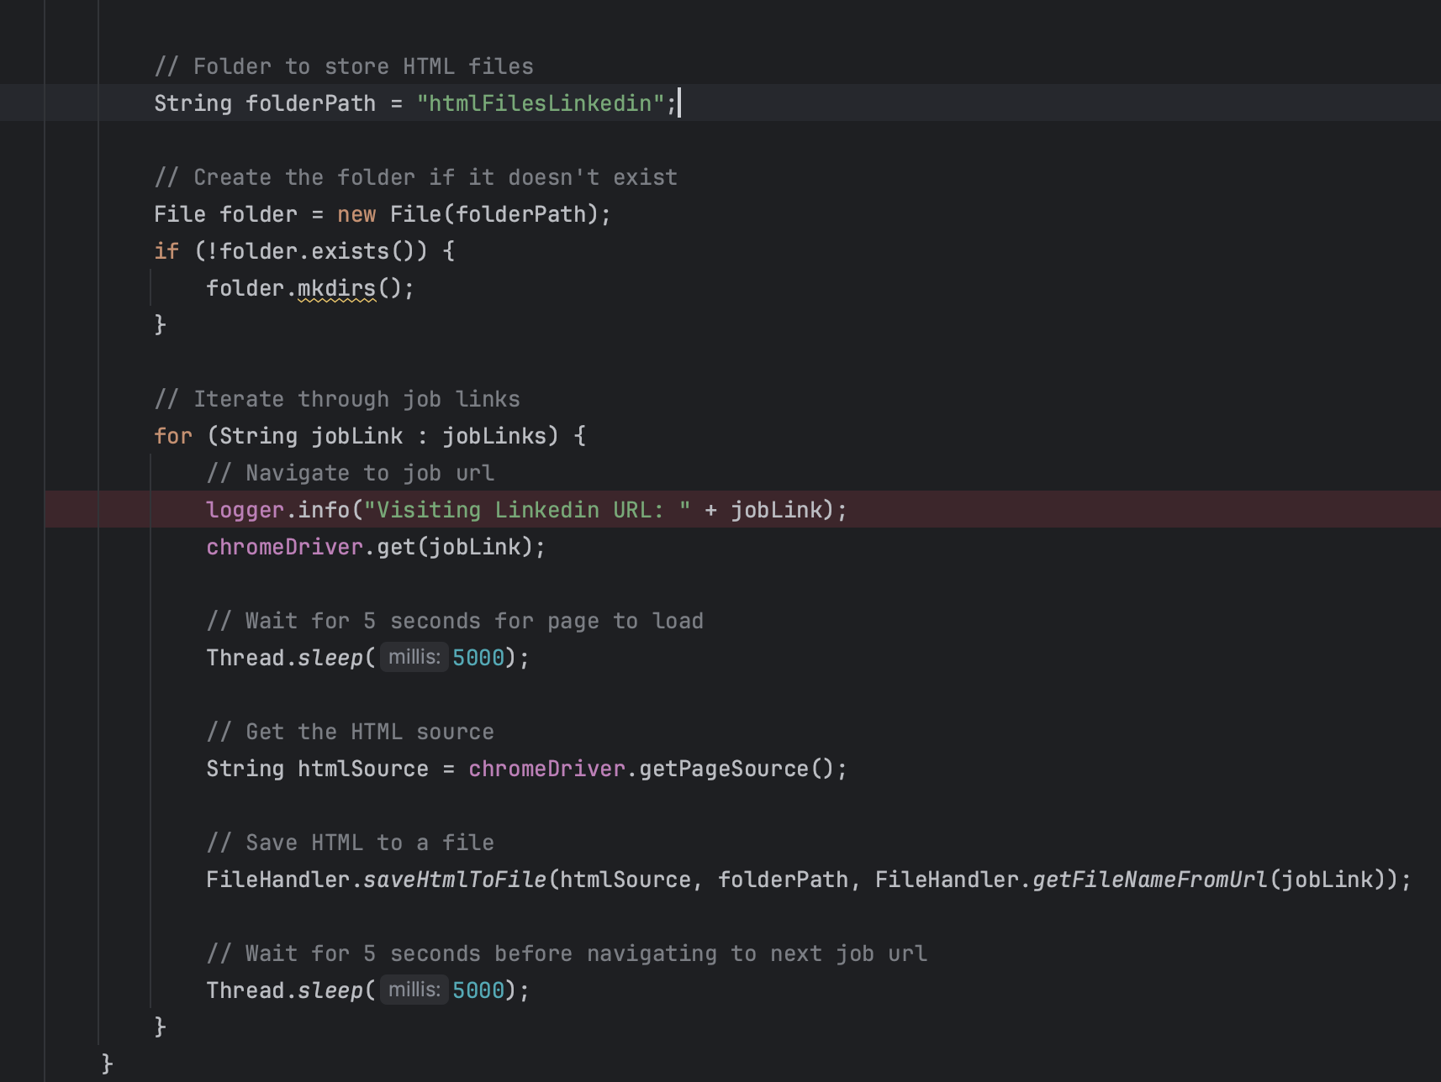

Output:

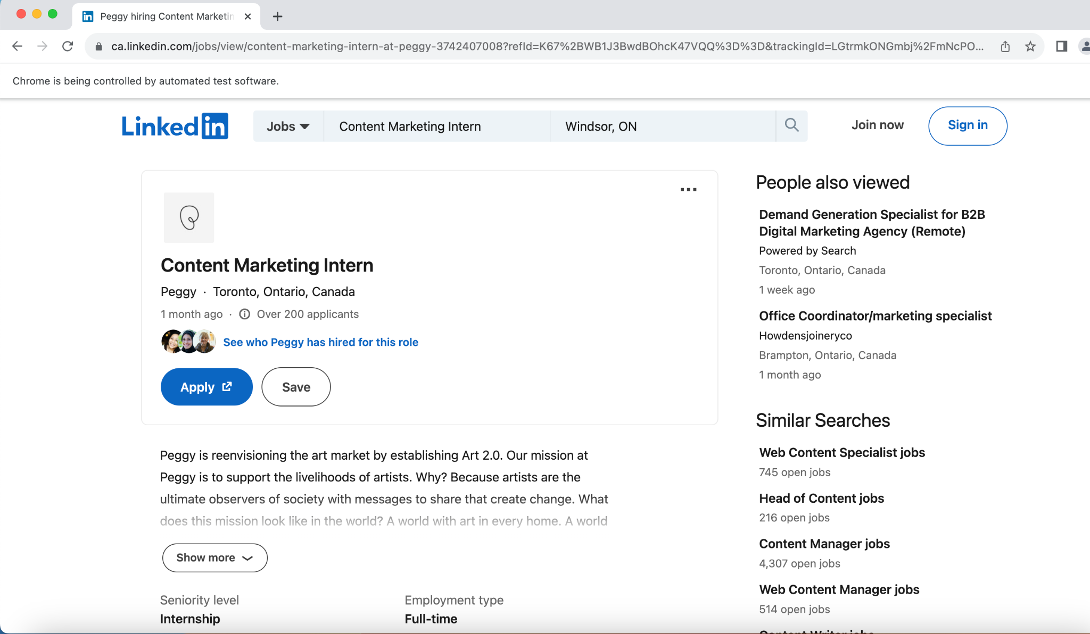

This downloads the HTML content onto the folder **htmlFilesLinkedin**

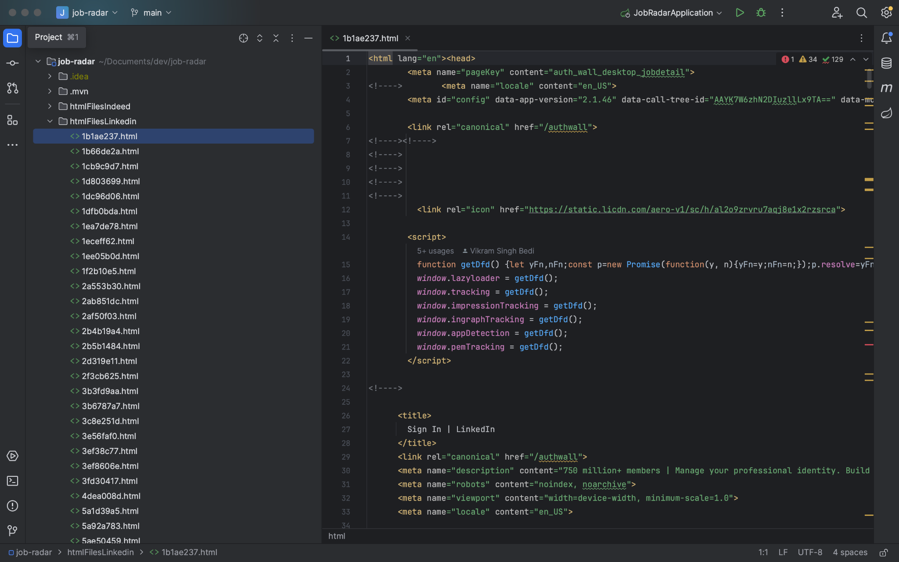

**Workopolis Crawler:**

The Workopolis Crawler is in the **WorkopolisCrawler.java** file

The Workopolis Crawler also has the function **getJobPosting** which takes jobTitle and location and input. We have provided **co-op** as the jobTitle and location as **Canada**

**Code**:

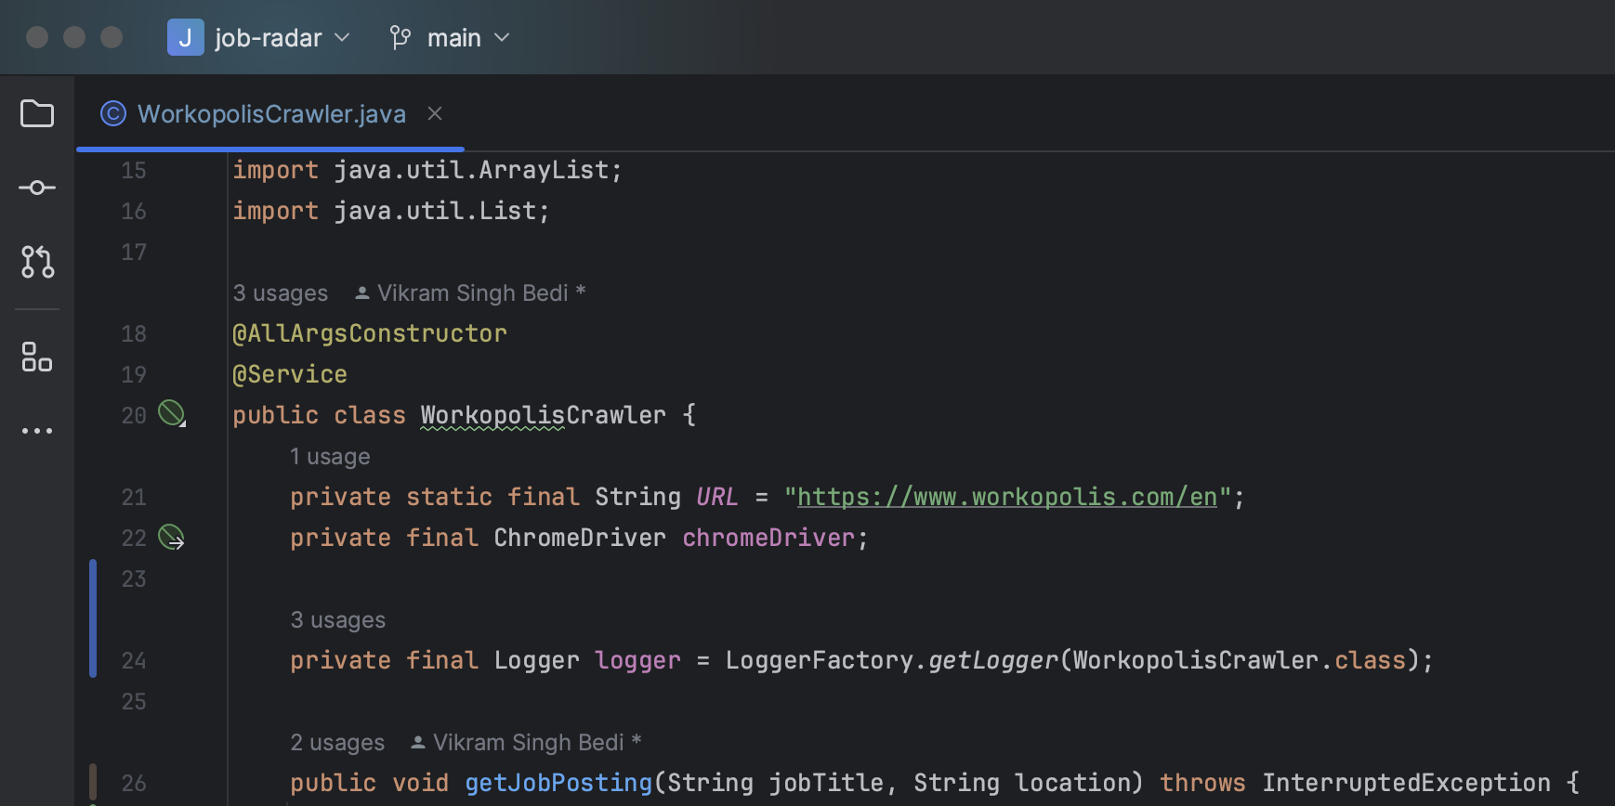

The web crawler first goes to the Workopolis URL using the **get()** function where we can search for jobs on Workopolis

Code:

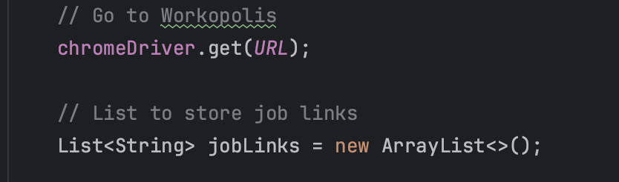

**Output**:

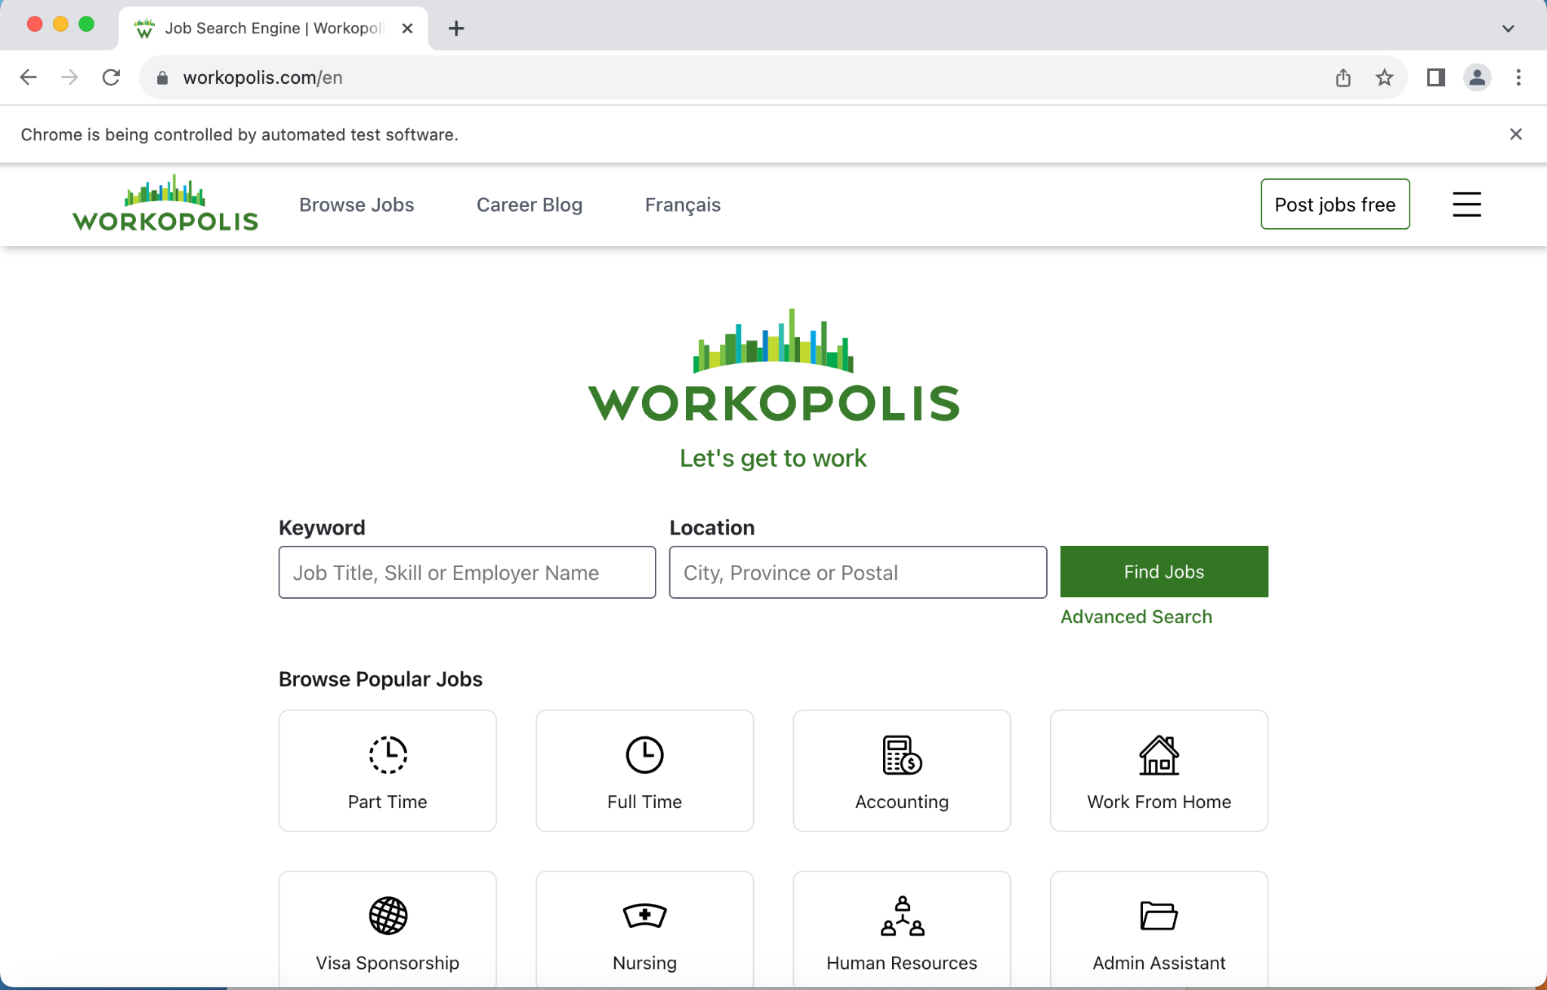

The crawler finds both the input boxes for job title and job location using the **findElement()** method. It then uses the **sendKeys()** method of selenium to provide input for both the input boxes and then uses **click()** to press the Find Jobs button which results in job postings with our given keywords ie. **co-op** and **Canada.**

Code:

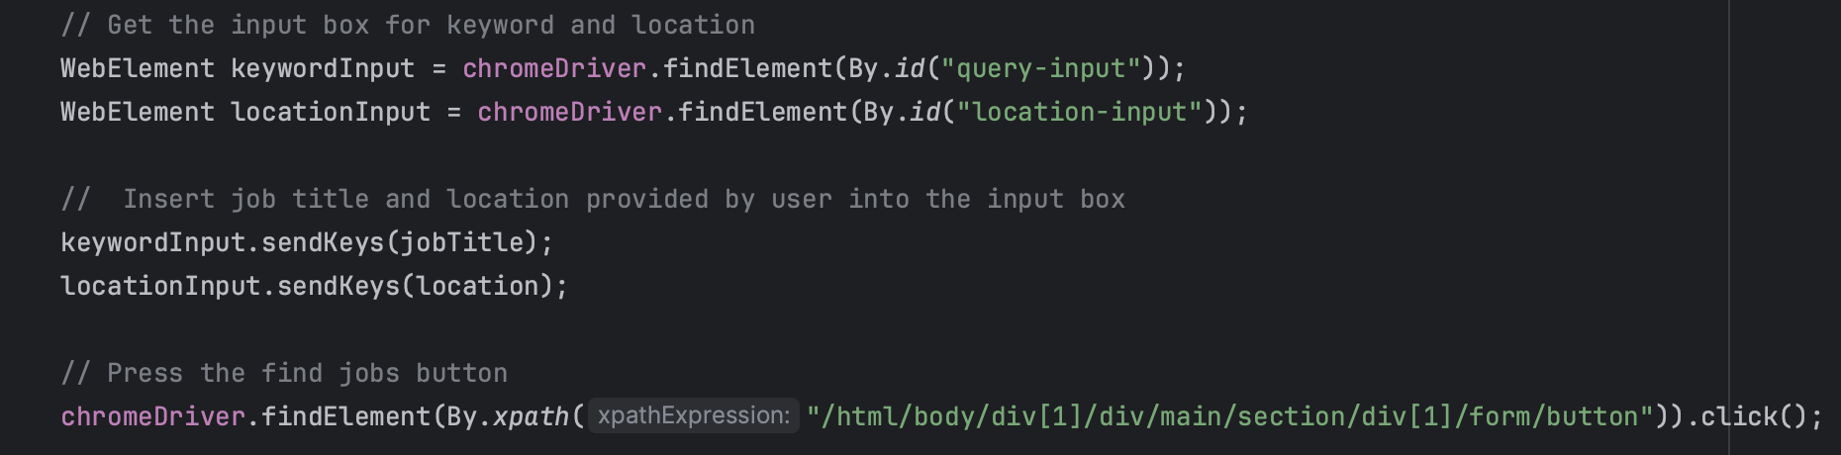

**Output**:

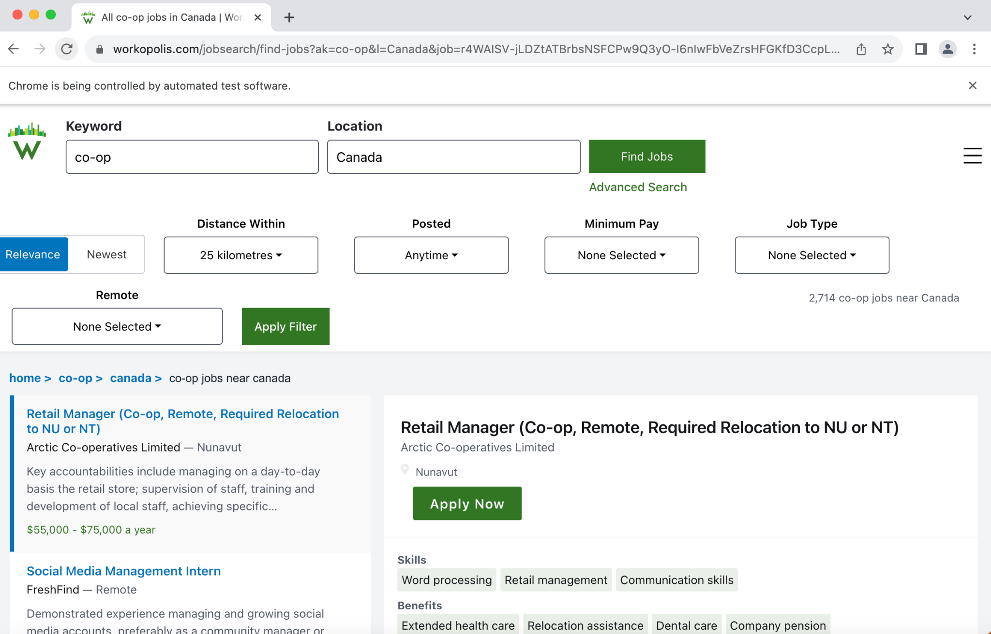

For each job posting, the crawler extracts its link from each job posting’s div element

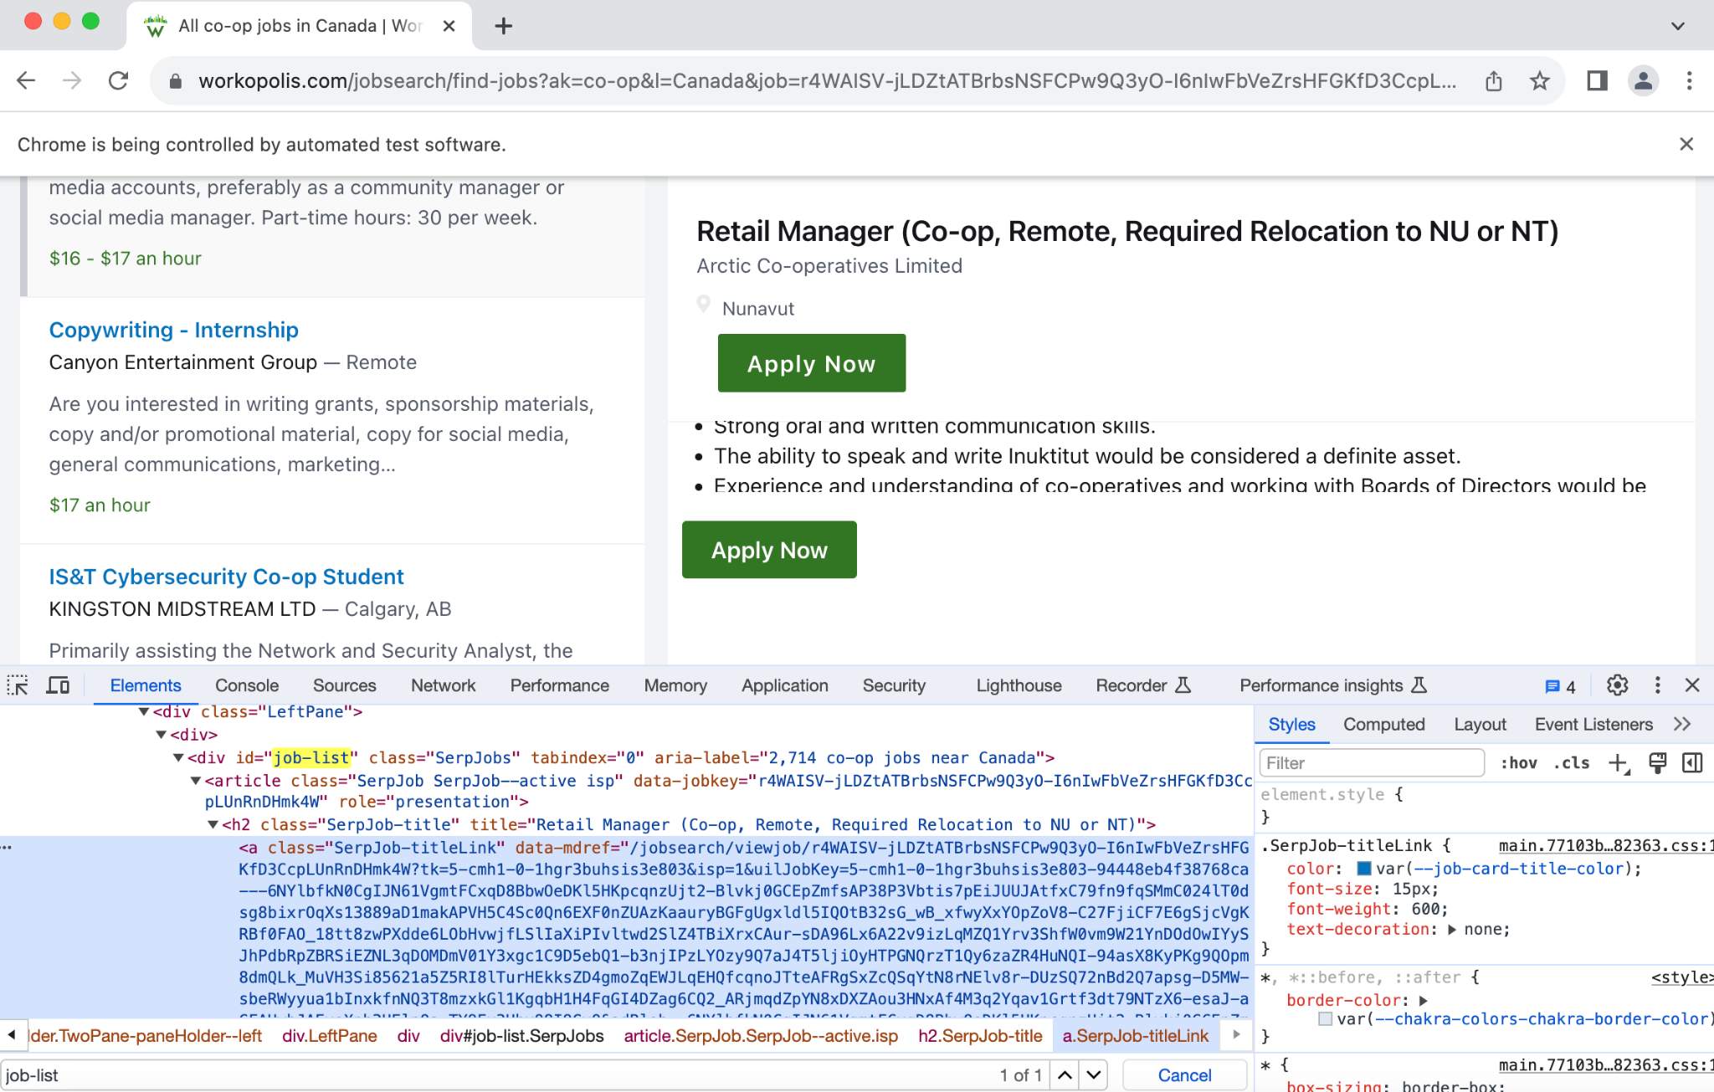

Then we press on the next button with the symbol **>** to go to the next page

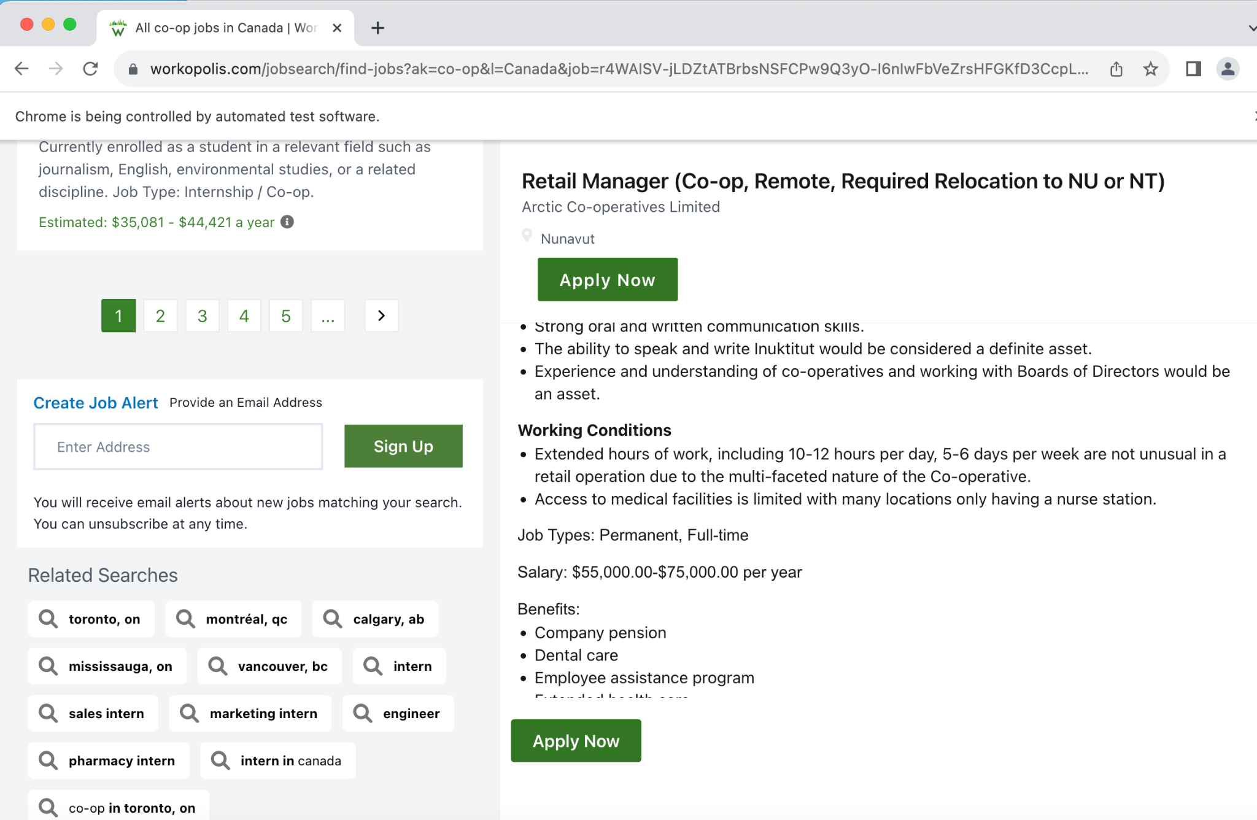

We do the same on the next page ie. extract the link for each job posting and add it to our list of URLs



We continue this process for 10 pages by pressing the next button.

Code:

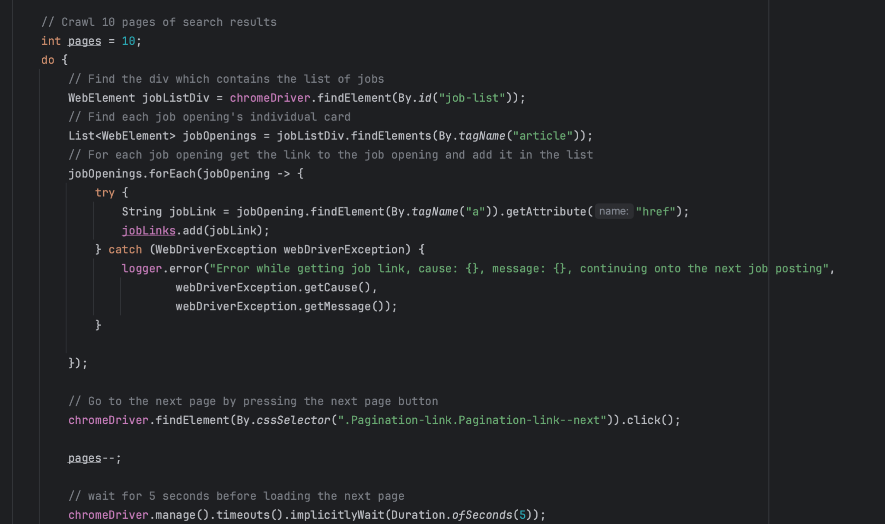

Then we traverse the list of job URLs open each job posting and download the HTML page onto the system.

Code:

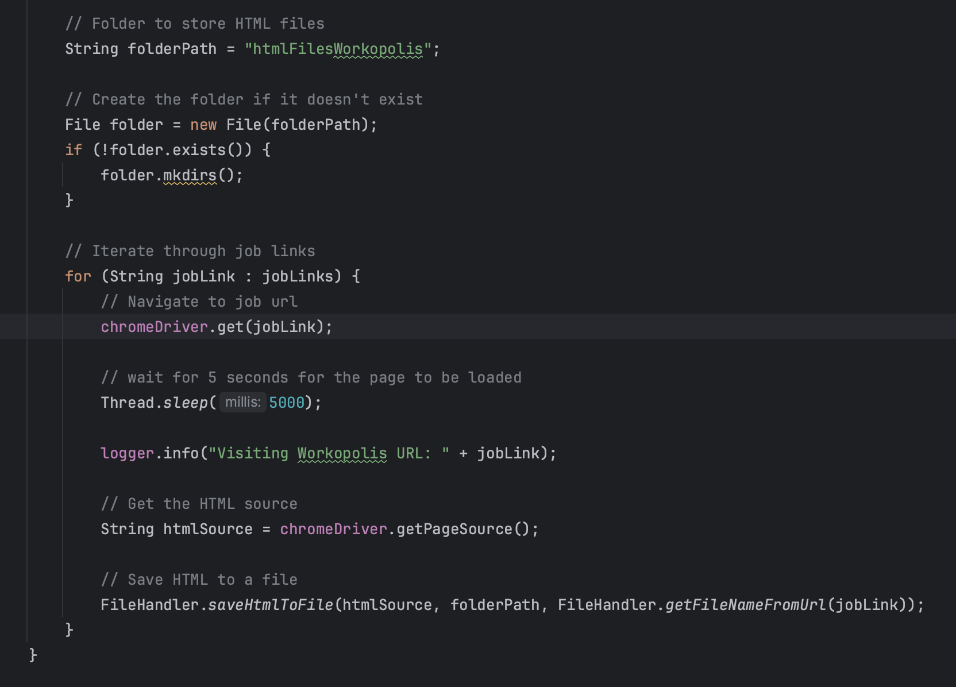

Output:

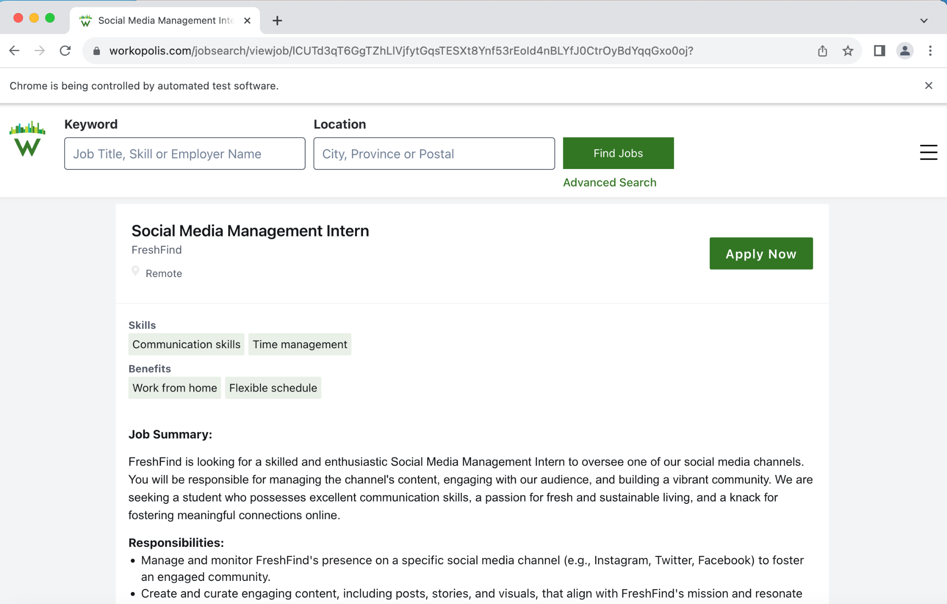

This downloads the HTML content onto the folder **htmlFilesWorkopolis**

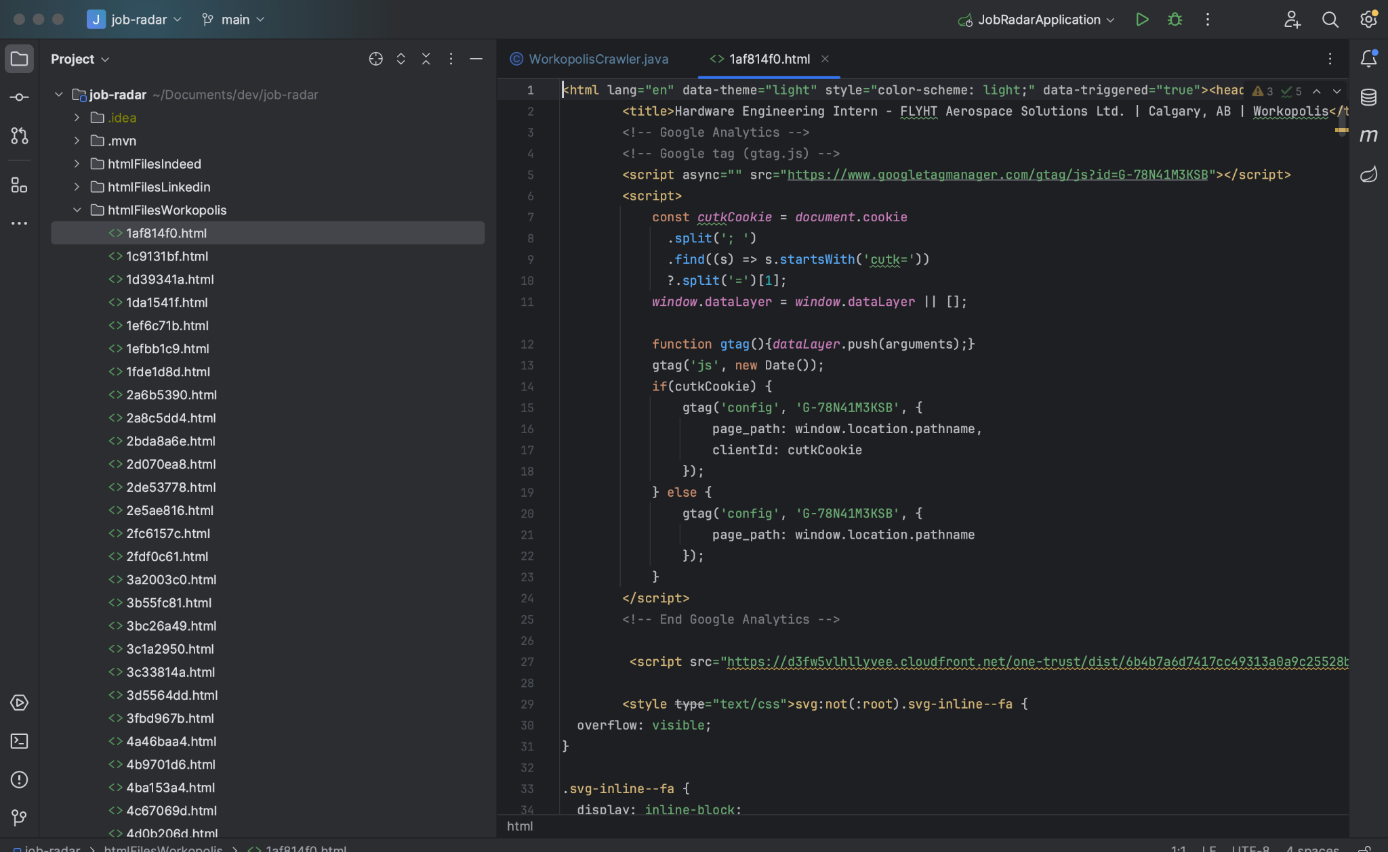

**Indeed Crawler:**

The Indeed Crawler is in the **IndeedCrawler.java** file

The Indeed Crawler also has the function **getJobPosting** which takes jobTitle and location and input. We have provided **co-op** as the jobTitle and location as **Canada.**

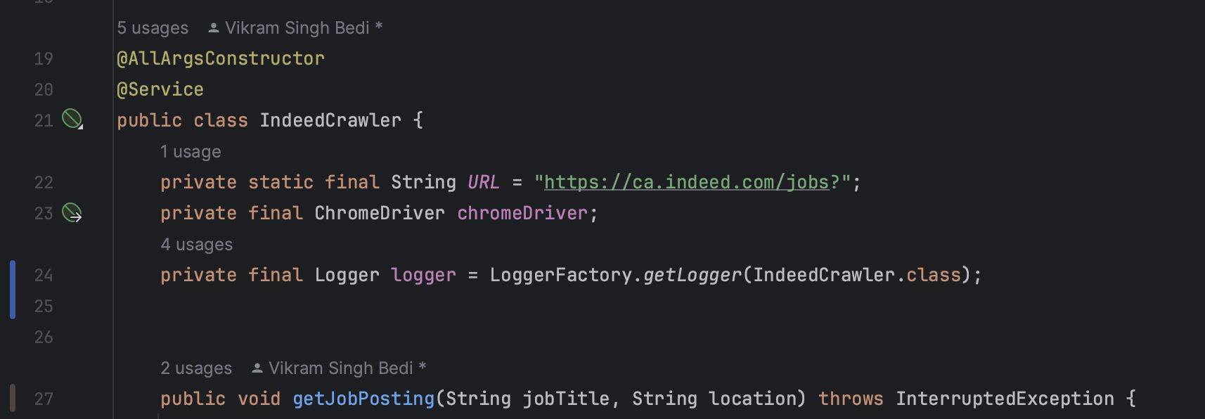

First we open indeed using the base url and job title and location embedded as query parameters in the url using the **get()** method which results in job postings with our given keywords ie. **co-op** and **Canada.**

Code:

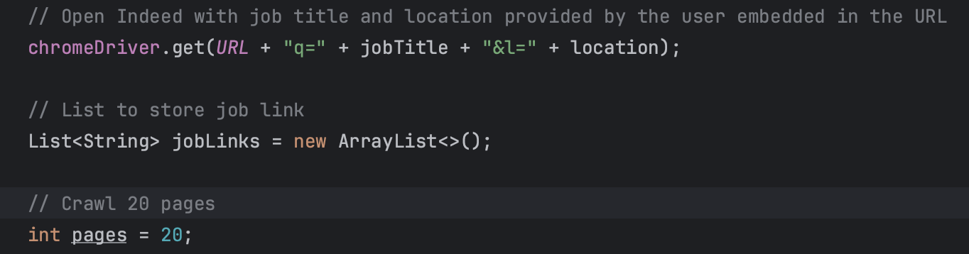

Output:

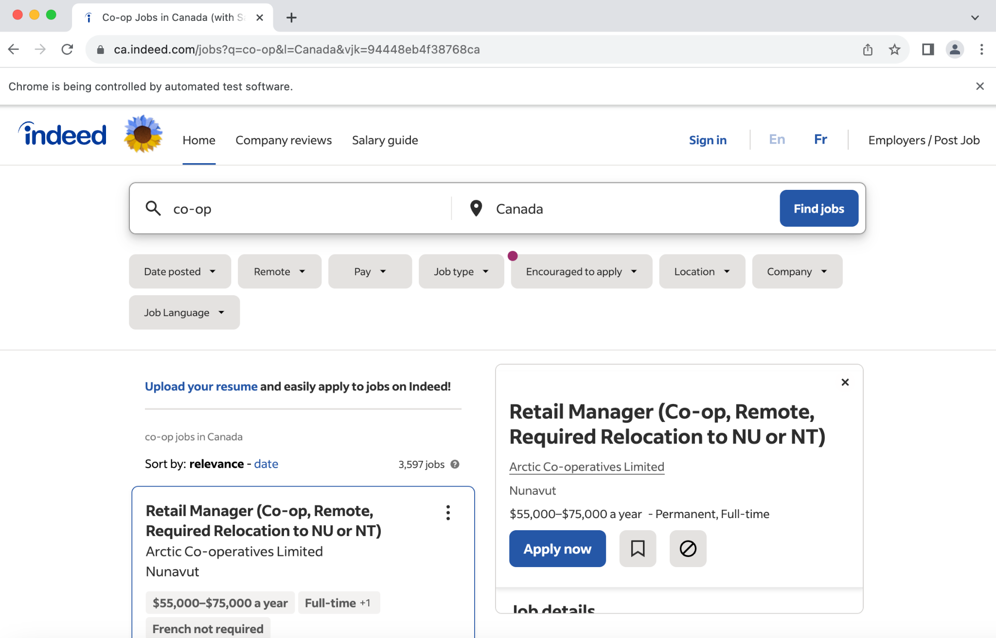

Next we store each individual job link in a list, we extract the job link from each job posting’s respective div

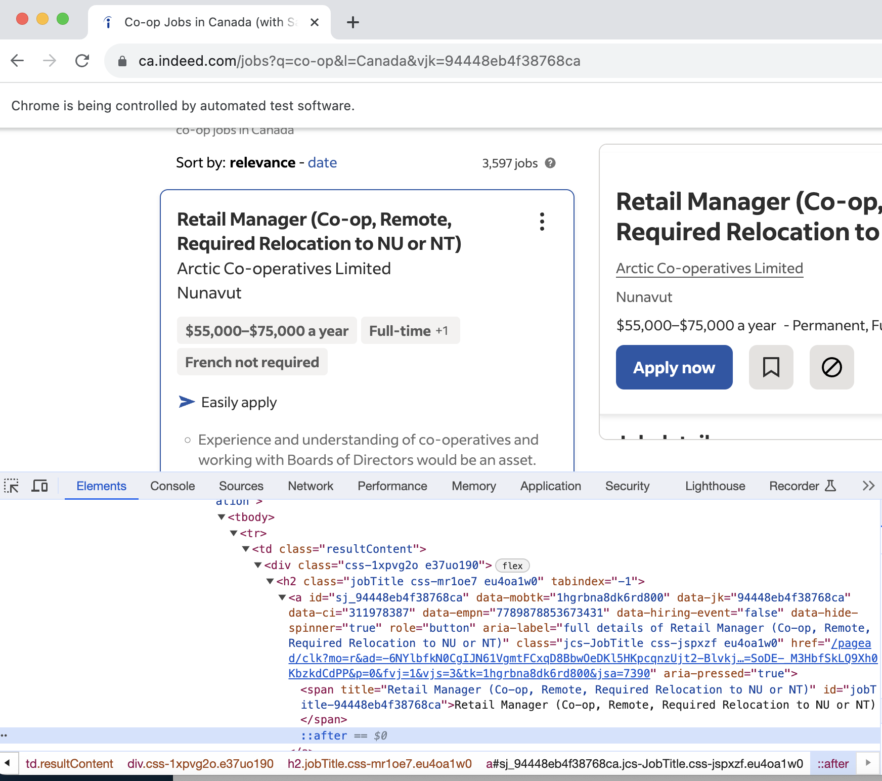

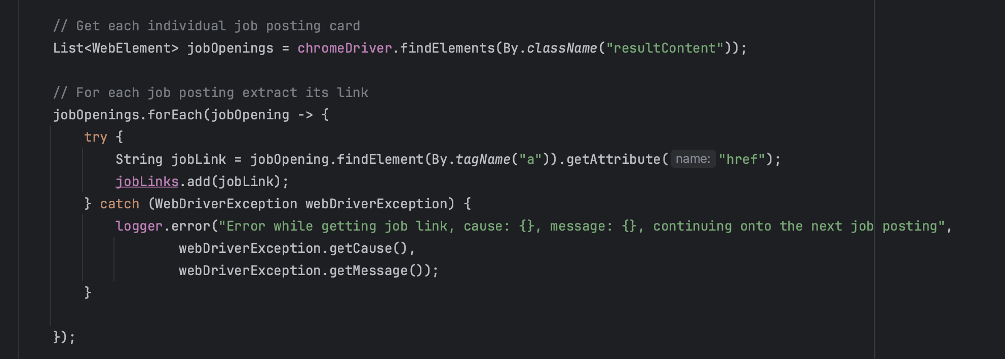

After storing all the job links in our list we go to the next page by clicking on the **>** button

Code:

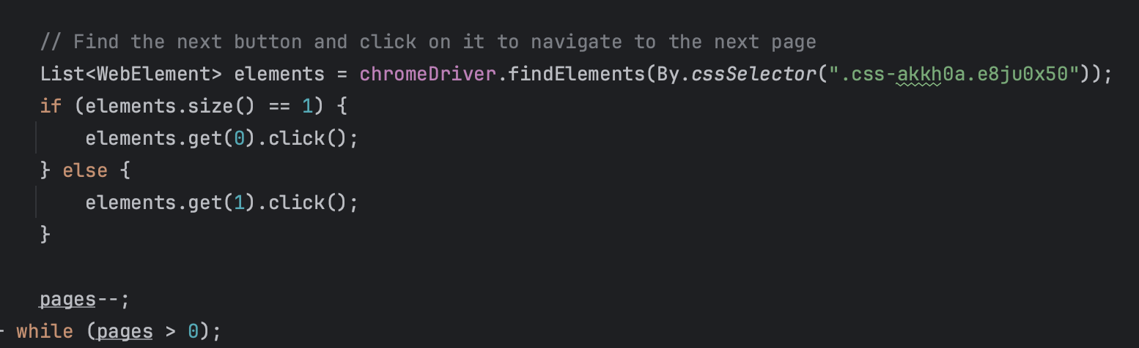

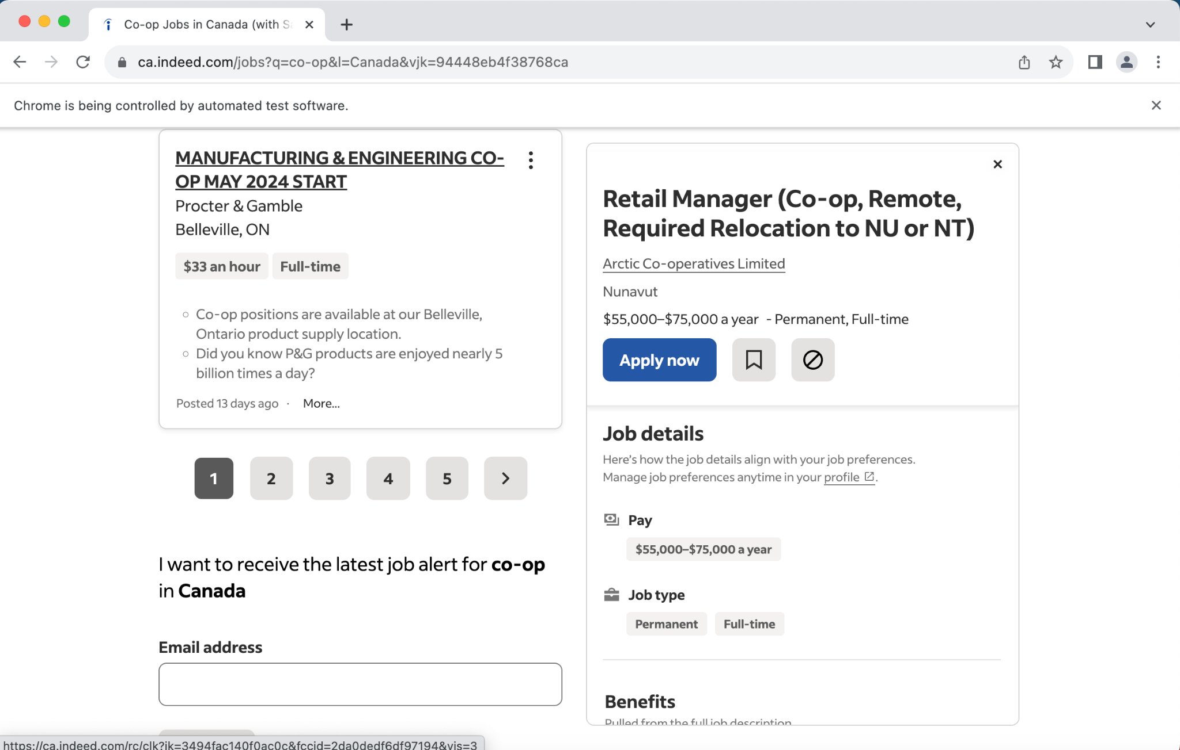

We do the same on the next page as well, ie. store all the job links in our list of URLs and then press the next button.

We repeat this process times, ie. we scrape 20 pages

After that, we traverse the list of job URLs open each job posting and download the HTML page onto the system.

**Code:**

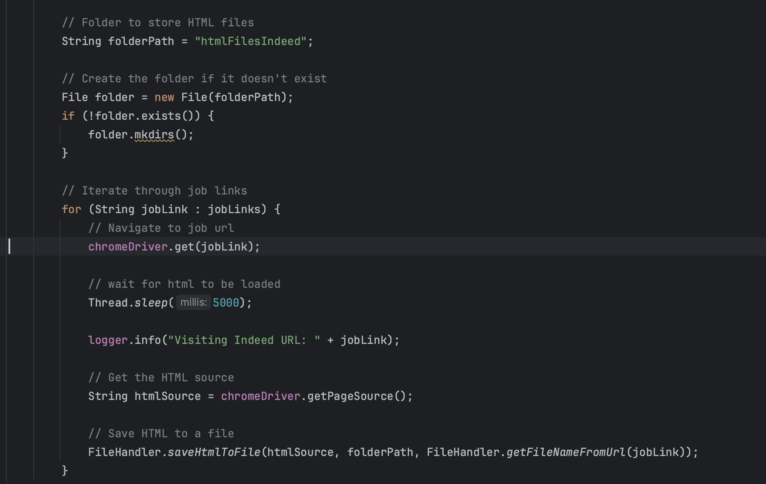

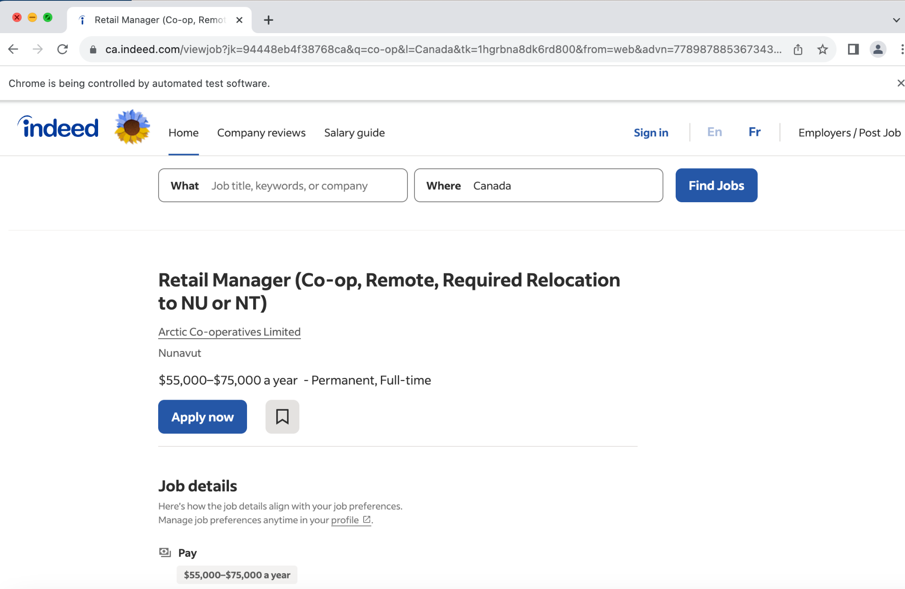

This downloads the HTML content onto the folder **htmlFilesIndeed**

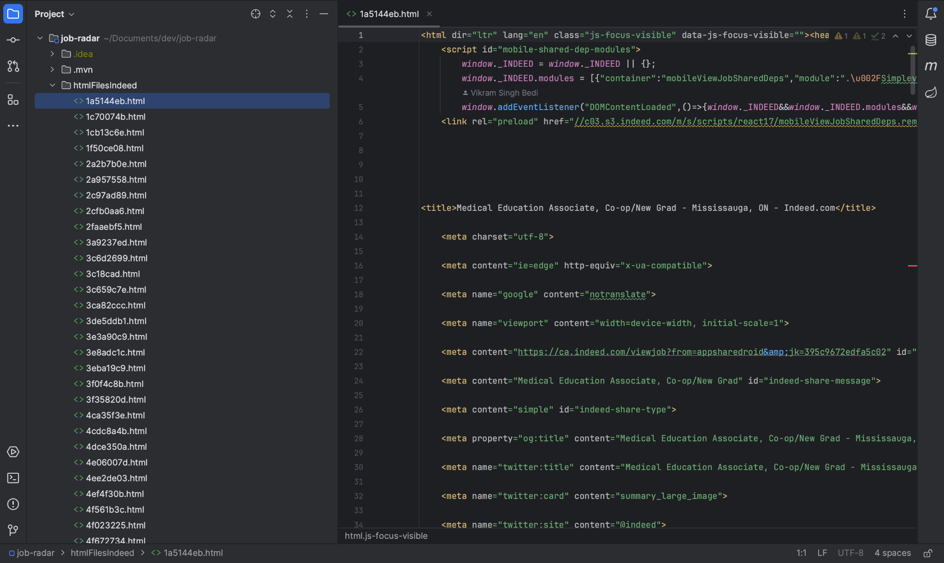

# 

# 2. HTML Parser

**Feature**: HTML parser  
**Developed by**: Miti Tamakuwala  
**Used Data Structure/Algorithm**: Jsoup library, HashMap  
**File names**: HtmlParserLinkedin.java, HtmlParserIndeed.java, HtmlParserWorkopolis.java, JobPosting.java

**Explanation:**

There are three separate classes named “HtmlParserLinkedIn”, “HtmlParserIndeed” and “HtmlParserWorkopolis” created for parsing crawled LinkedIn, Indeed and Workopolis files respectively.

**1)** **Necessary Imports**:

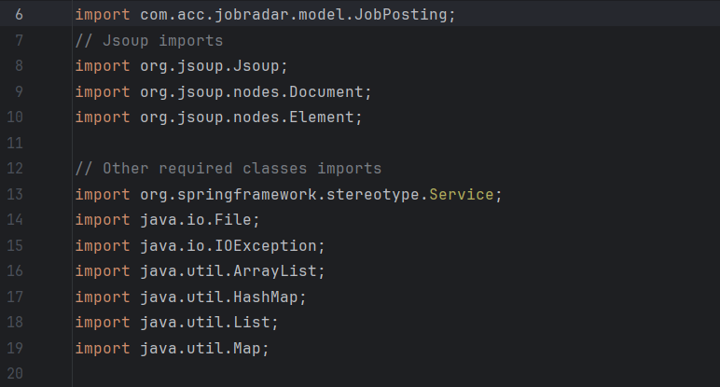

**2)** **Working of HTML parser:**

**parseIndeedHtmlFiles**: This method is invoked to initiate the parsing of HTML files.  
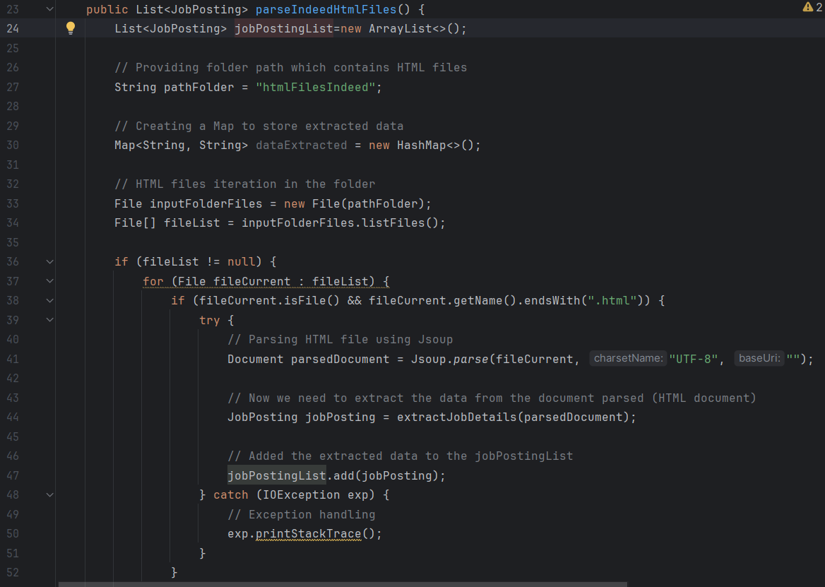

**Setting the path of the input folder**: The path to the folder containing HTML files (htmlFilesIndeed) is specified.

**jobPostingList**: An empty List<JobPosting> is created to store parsed job details.

**dataExtracted**: A HashMap <String, String> is initialized for storing the extracted data temporarily.

**Retrieve HTML files:** The code retrieves a list of HTML files from the specified folder (htmlFilesIndeed). Additionally, we must verify that every file in the list is valid and should end with ".html".

**Parsing - Jsoup library**: The HTML document from the current file is parsed using the Jsoup java library, and the parsed document is saved in the "parsedDocument" variable.

**Extracting Job details (extractJobDetails)**:  
The job details (Job title, Company name, Company location, Job description, Application link) are extracted by calling the extractJobDetails method by passing the parsed HTML document as an argument. The extractJobDetails method uses CSS selectors to extract all the required job details. It extracts the text content from the HTML elements selected and all the probable variations in HTML structure are accounted for efficient extraction.

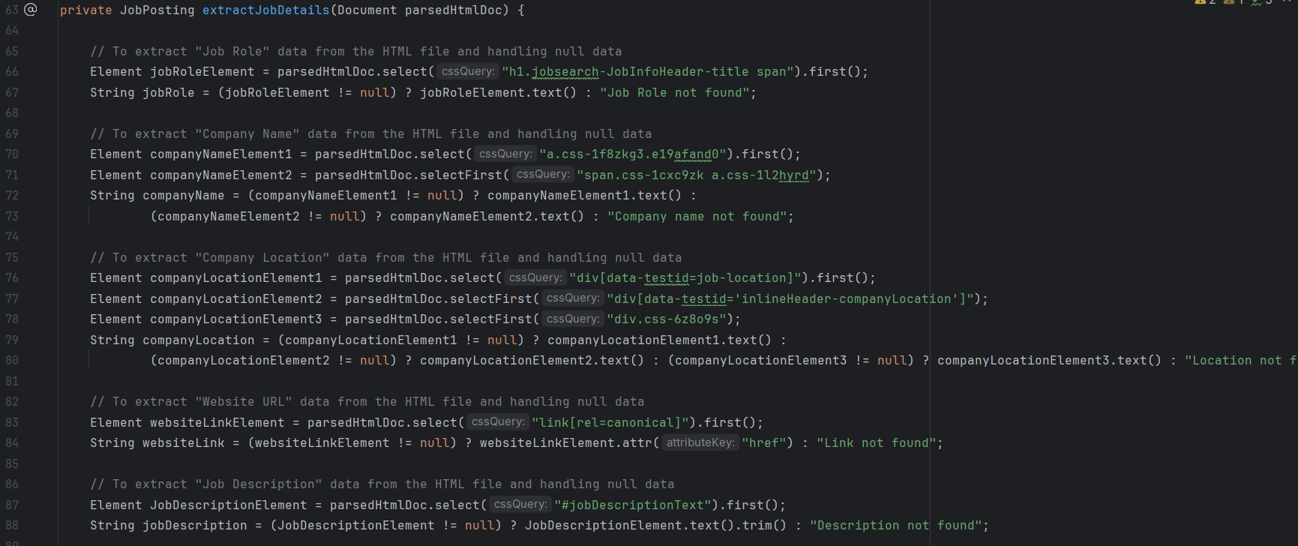

**Job posting Object:**Created a new object named JobPosting with the job details extracted and added the object to the jobPostingList. The object includes job role, company name, location, job description, and website link.



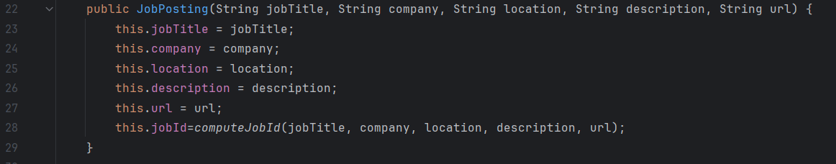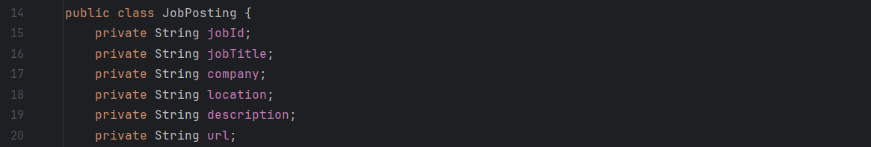

**3)** **Reasoning for Data Structure/Algorithm:**

* A **List<JobPosting>** to efficiently store multiple job details (Job role, Company name, Company location, Job Description and Application URL)
* A **HashMap<String, String>** to provide flexibility during temporary data storage during data extraction.
* Jsoup is a great choice for HTML parsing because of its ease of use and versatility.
* Used CSS selectors because they work well for extracting targeted elements.

**4) Exception Handling**:

Catches and prints a stack trace if an IOException occurs during HTML parsing.

**Checking the existence of the input folder:**   
Check if the input folder (htmlFilesIndeed, htmlFilesLinkedin, htmlFilesWorkopolis) exists at the specified path and is not empty. It is handled by printing a message "The ‘htmlFilesIndeed” folder does not exist or is empty!! ".

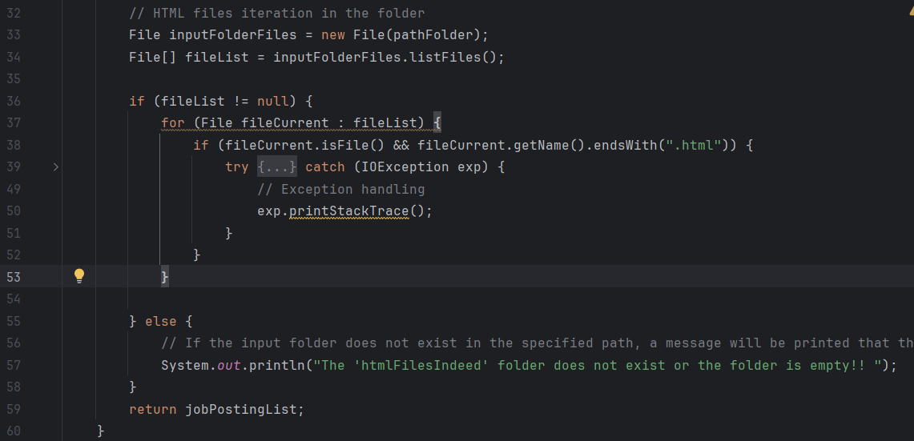

The same workflow is for “HtmlParserLinkedIn.java” and “HtmlParserWorkopolis.java” files as well.

**5) Output**: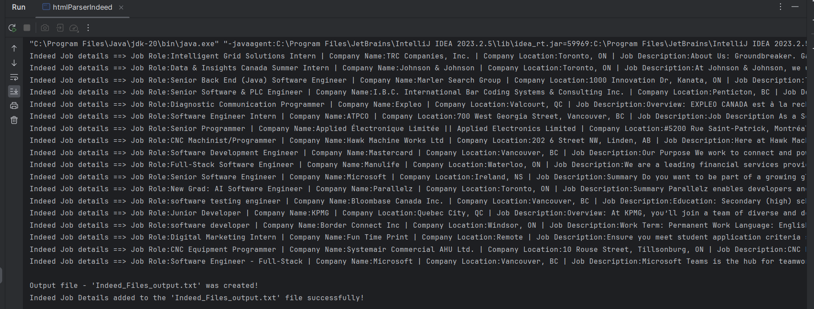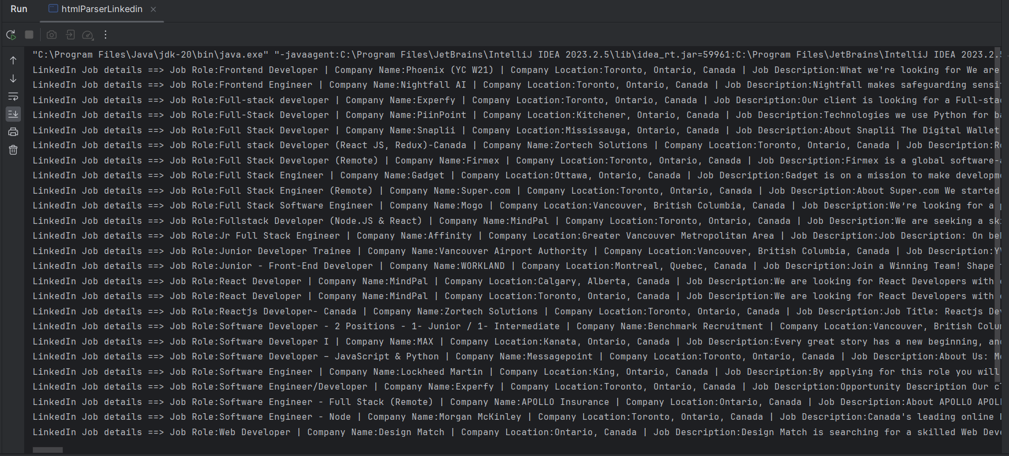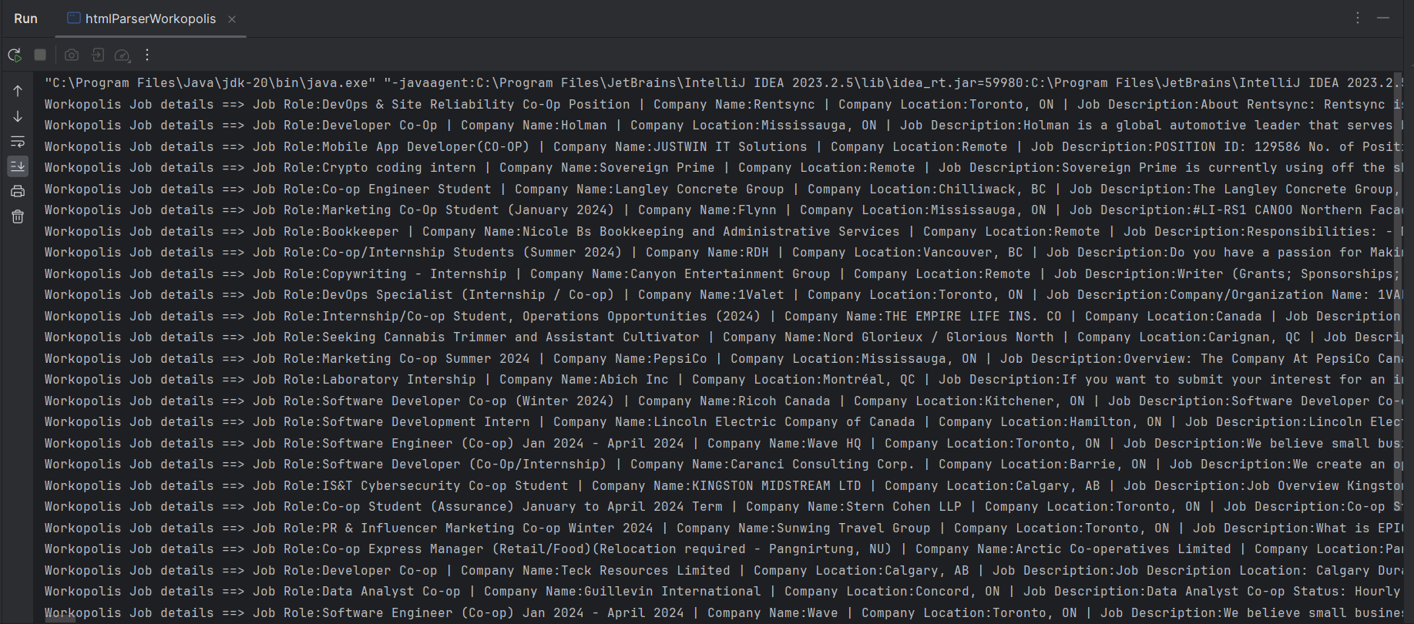

HTML Parsing Output

# 

# 3. Data validation using regular expressions

Data validation of data fetched

**Developed by:** Meet Patel

**File Name:** DataValidator.java

1. Method ‘validateData’
   * **Description:** This method validates a JobPosting object by checking if any of its essential fields (company name, job title, location, and job description) contain default or "not found" values. Additionally, it verifies the validity of the provided website link.
   * **Returns:** true if all fields are valid; otherwise, false.
   * public static boolean validateData(JobPosting data)
   * {
   * boolean containsCompanyName = data.getCompany().equals(StringConstants.*CompanyNotFound*);
   * boolean containsJobTitle = data.getJobTitle().equals(StringConstants.*JobTitleNotFound*);
   * boolean containsLocation = data.getLocation().equals(StringConstants.*LocationNotFound*);
   * boolean containsJobDescription = data.getDescription().equals(StringConstants.*DescriptionNotFound*);
   * boolean isValidWebsiteLink = *isValidWebsiteLink*(data.getUrl());
   * return !containsCompanyName && !containsJobTitle && !containsLocation && !containsJobDescription && isValidWebsiteLink;
   * }
2. isValidWebsiteLink(String input)
   * **Description:** This method checks whether the given input string represents a valid website link. It uses a regular expression to validate that the link starts with either "http://" or "https://://".
   * **Returns:** true if the input is a valid website link; otherwise, false.

public static boolean isValidWebsiteLink(String input)

{

String regex = "^(http|https)://.*$";

Pattern pattern = Pattern.*compile*(regex);

Matcher matcher = pattern.matcher(input);

return matcher.matches();

}

# 4. Inverted Indexing

**Developed by:** Vikram Singh Bedi

**Libraries/Data Structure/Algorithm Used:** Trie, HashMap, Array

**Files:** InvertedIndex.java, TrieNode.java, InvertedIndexController.java

**Explanation:**

An inverted index is a data structure used in information retrieval to efficiently store and retrieve a mapping between words and the documents that contain them. It is called "inverted" because it inverts the relationship between documents and terms compared to a simple forward index.

In our particular use case, our inverted index will store words and job postings that contain those words. Given a word, our inverted index will return a list of job postings with those given words.

Instead of returning the list of job postings, the inverted index will return the list of job IDs, the database can then fetch job postings corresponding to these job ids.

**Choice of underlying data structure:**

We can implement inverted index using a HashMap or a Trie data structure. I’ve used Trie data structure to implement the inverted index. Here’s a comparison of Trie vs HashMap in context of implementing an inverted index.

* **Search Efficiency:**
* Tries excel at prefix searches, making them efficient for scenarios where terms share common prefixes. This is beneficial when searching for terms with specific prefixes.
* Hash maps provide constant-time average-case search performance, but they are less efficient for prefix searches since there is no inherent order or structure in hash map keys.

**Space Efficiency:**

Tries can be space-efficient, especially when dealing with terms that share common prefixes. The structure of tries allows for the storage of shared prefixes only once, reducing memory requirements.

Hash maps may require more memory, especially when there are collisions. Each key-value pair is stored independently, and if many keys hash to the same location, it can lead to increased memory usage.

**Insertion and Deletion Performance:**

Tries generally offer fast insertions and deletions, making them suitable for dynamic scenarios where the index is frequently updated.

Hash maps also provide fast average-case insertion and deletion times, but performance may degrade in the presence of collisions, requiring additional handling.

**Implementation:**

The structure of TrieNode is defined in TrieNode.java class.

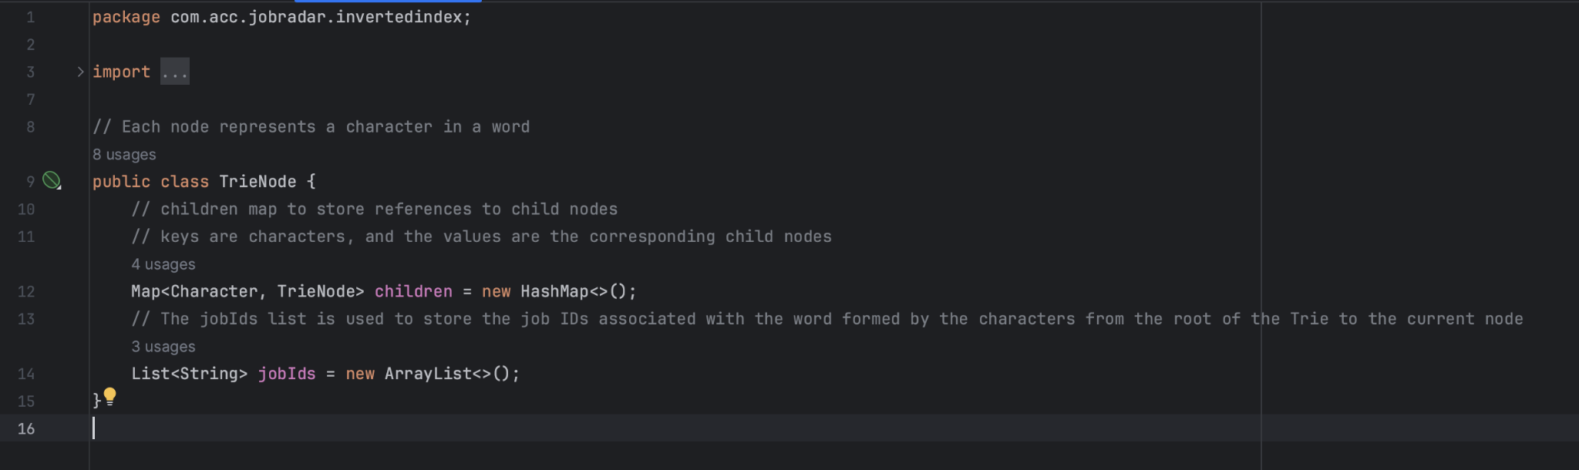

The TrieNode class represents a node in the trie. Each node contains a map (children) to represent its child nodes, and a set (jobIds) to store the job IDs associated with the words formed so far.

**Trie Index Building:**

The buildIndex method takes a list of JobPosting objects and extracts job title, company, location, and description. Words from these fields are then inserted into the inverted index using the insertWords method.

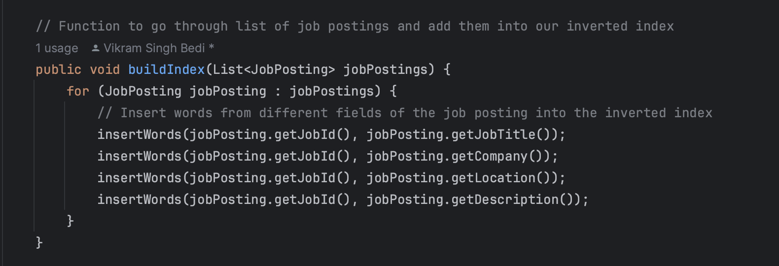

The insertWords method utilizes a TextParser to extract individual words from the provided text, excluding common stop words and removing non alphabetical characters. Each word is then converted to lowercase, and the insert method is called to insert the word and its associated job ID into the trie.

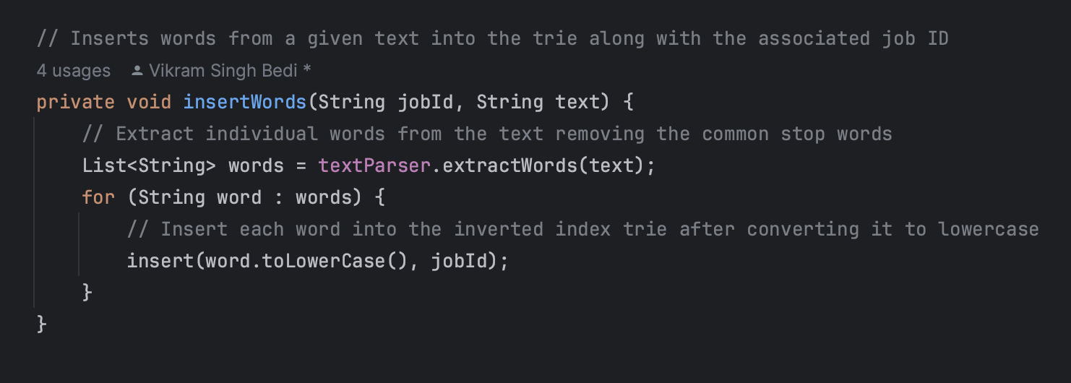

**Trie Insertion:**

The insert method traverses the trie for each character in the given word. A new TrieNode is created if the character is not already a child of the current node. The traversal continues, and the job ID is added to the jobIds set at each node to support partial matches

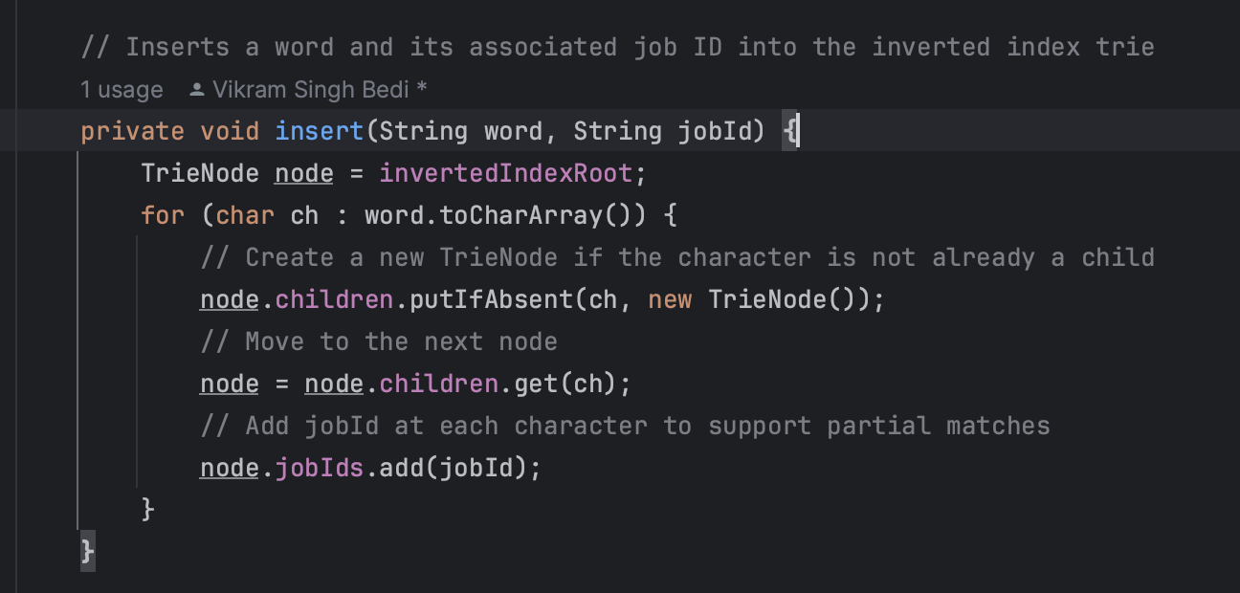

**Trie Searching:**

The search method is used to look up a word in the inverted index. It traverses the trie for each character in the given word, and if the word is found, the associated job IDs are returned. If the word is not found, an empty list is returned.

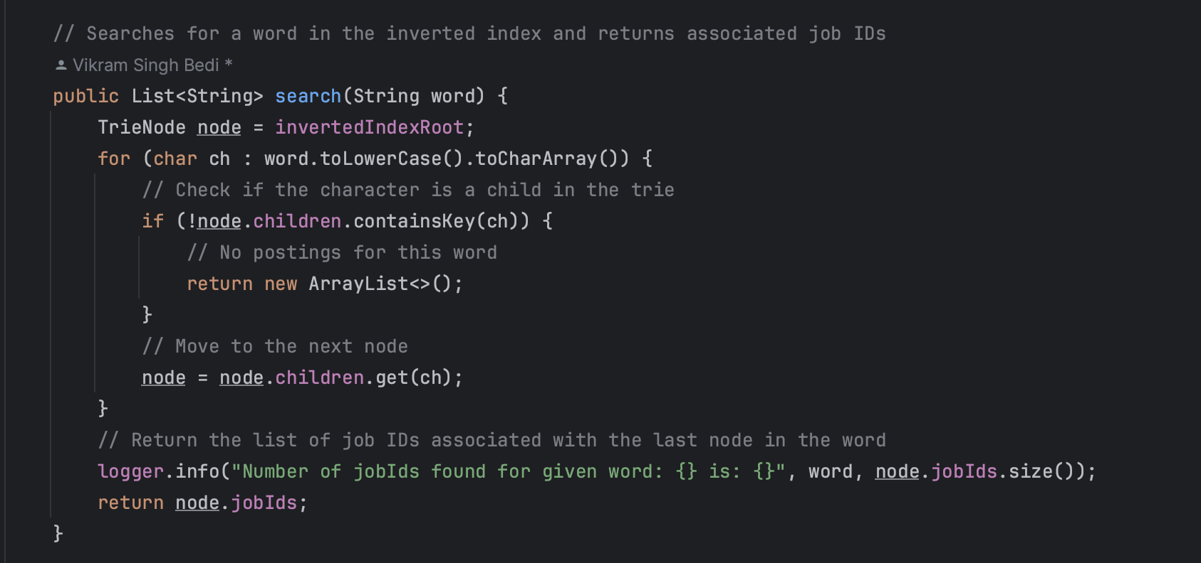

**Output:**

If we search for marketing it returns the list of job postings containing the word marketing

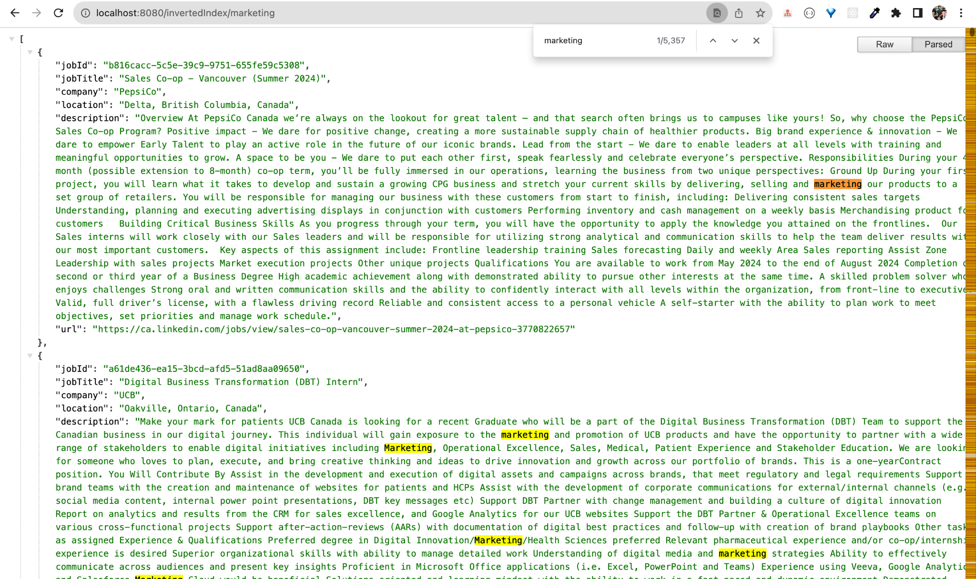

In case the user types a partial word like marketi it supports partial matching to return job postings with word marketing in them

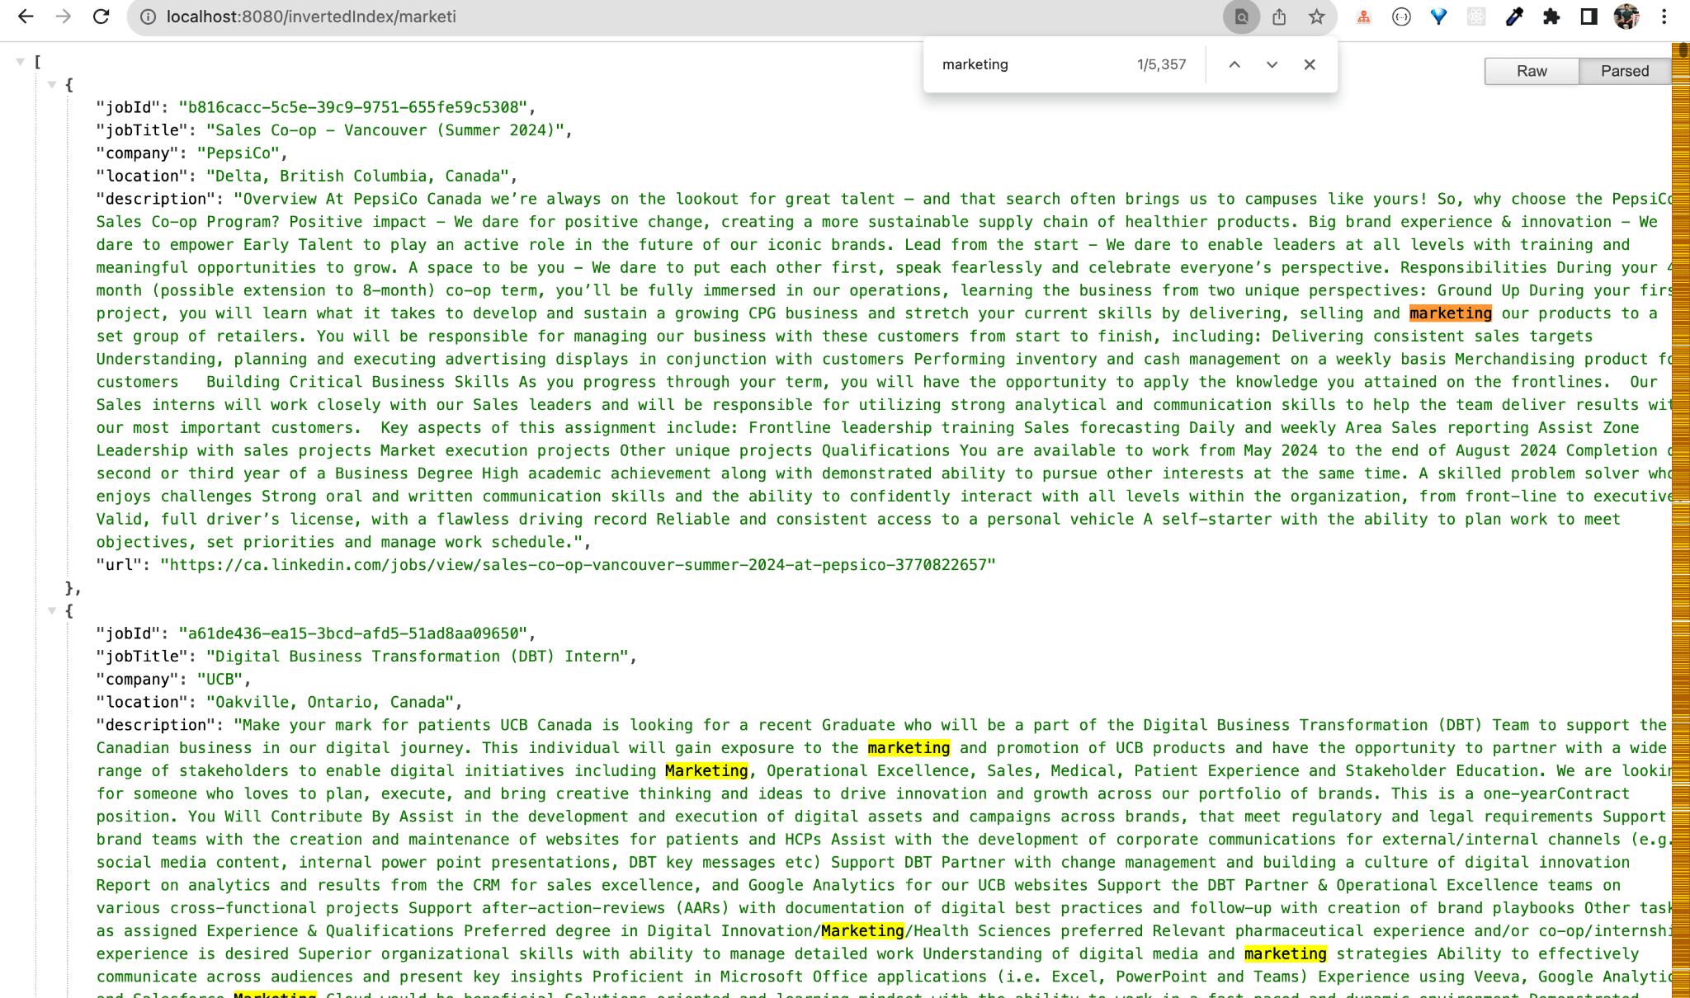

# 

# 5. Frequency count

**Feature**: Frequency Counter

**Developed by**: Apoorv Shamma

**Purpose**: The main purpose of this feature is to show the user the no. of times a word occurred in a given URL. For us, it will be a Job posting.

**Data Structure/Algorithm Used**:   
ArrayList - used to store keywords entered by the user.  
HashMap - used to store the frequency of given word in particular Job Posting.

**File Nam**e: FrequencyCounter.java

**Explanation:**

The FrequencyCounter class provides a service for calculating the frequency of a given word in job postings. It is dependent on an inverted index and a database.

Methods used:

* getWordFrequency(String word): Map<String, Integer>  
  This method takes a word as input and returns a map containing job IDs and the frequency of the given word in the corresponding job postings.
* getWordFrequencyInJobPosting(JobPosting jobPosting, String word): int  
  This private method calculates the frequency of a word in a specific job posting. It takes a JobPosting object and a word as input and returns the frequency as an integer. JobPosting object holds data such as jobId, Title of the job, company name, location, Job description, and URL.

Initialization:

The class constructor takes an InvertedIndex and a Database as parameters, initializing them for later use.

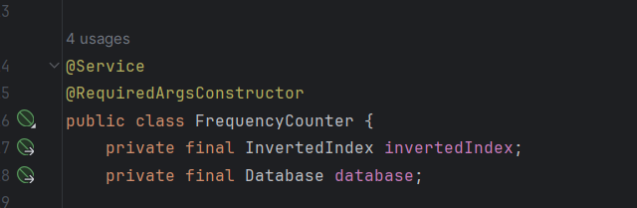

Methods Explanation:

* getWordFrequency(String word): Map<String, Integer>

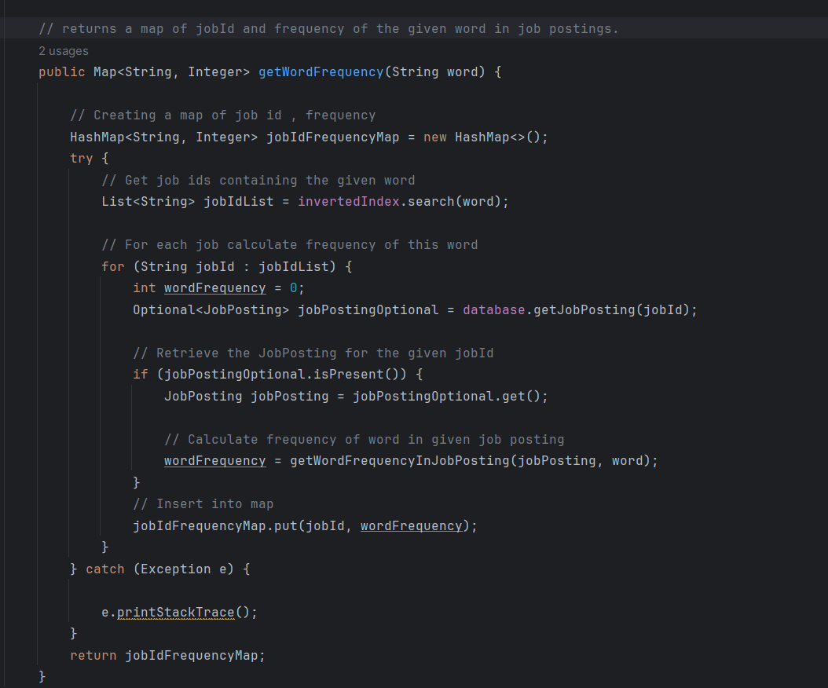

The getWordFrequency method operates in several steps:

It first identifies job IDs containing a specified word using the inverted index. It then retrieves the corresponding job postings from the database. If a job posting exists in the database, the method proceeds to invoke a private function (getWordFrequencyInJobPosting) to compute the word frequency for each job posting. The results are then stored in a map named JobIdFrequencyMap, associating job IDs with their respective word frequencies. Finally, the method returns this populated map, containing job IDs and their corresponding word frequencies.

* getWordFrequencyInJobPosting(String word): Map<String, Integer>

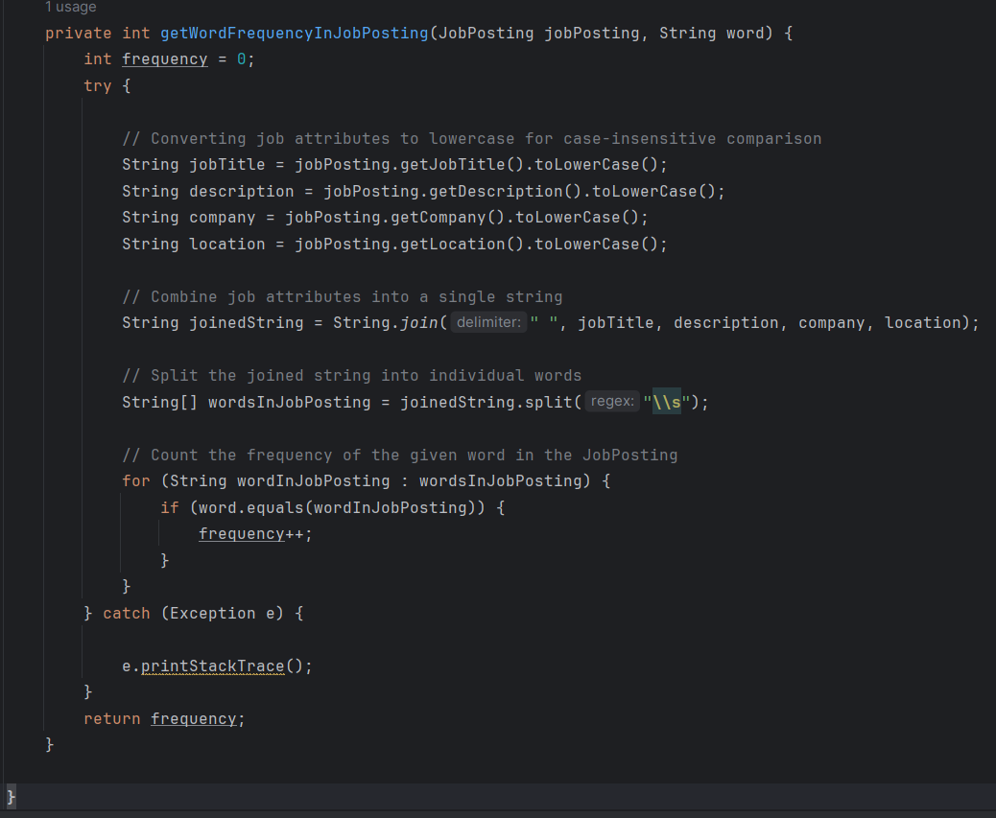

The method is coded to know how frequently a particular word occurs in a job posting. Job posting consists of the title of the job, company name, location, and Job description. It takes two inputs - a JobPosting object and a specific word. The method starts by converting different attributes of the job posting, like the job title, description, company, and location, into lowercase. This will help us to do case-insensitive comparisons. It then combines them into a single string and then counts occurrences of the specified word in that string. The function returns the frequency of that word in particular Job Posting.

**Reasoning for Data Structure/Algorithm:**

HashMap: The data structure is best when dealing with frequencies. It allows fast retrieval of frequencies associated with each job IDs. The ability to make pairs of keys and values helped us associate each job ID with its corresponding word frequency. Also, It has constant time complexities of common operations like insertion, deletion, and searching.

**Exception Handling:**

Catches and prints a stack trace if any Exception occurs during Frequency count.

**Output:**

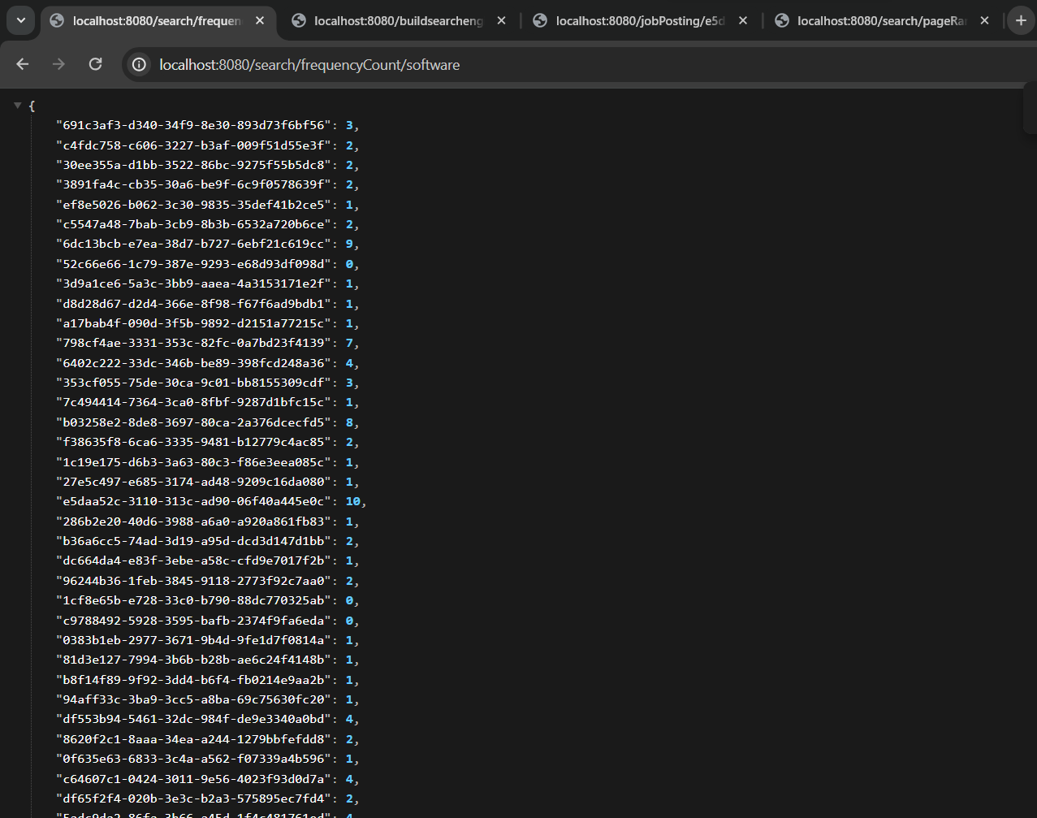

The output shows the JobID and frequency count of the search word. In our case, it is “software”.

# 6. Page ranking

**Feature Name:**  Page Ranking

**Developed by:** Apoorv Shamma

**Purpose:** The main purpose of this feature is to rank web pages based on user search strings. The PageRanking algorithm works on the no.of occurrence of user search strings in respectively. The webpage with more Search terms will receive a higher ranking than those pages which has less count of these search terms.

**Data Structure/Algorithm Used:**

**Priority Queue** - The **Priority Queue** is used in this code to efficiently maintain a sorted order of job IDs based on their cumulative word frequencies. Priority Queue is implemented using a max heap.

**HashMap** - The **HashMap** in this code is used to efficiently store and update the cumulative frequencies of each job ID based on the words in the search string.

**File Name:** PageRanking.java

**Explanation:**

The **PageRanking** class provides a service for assigning the page ranks to job postings based on the frequency of words in a search string. It is dependent on the frequency counter class.

**Methods used:**

* **getPageRanks(String searchString): List<String>**

The getPageRanks method takes a search string as input and returns a list of job IDs sorted by their total frequencies. It calculates word frequencies in job postings, updates a total frequency map, and uses a priority queue for sorting. The function handles exceptions during frequency calculation.

**Initialization:**

The class constructor takes a FrequencyCounter as a parameter, initializing them for later use. The JobFrequencyPair class is a nested class representing a pair of job ID and frequency and we used this in sorting the priority queue.

# 

Methods Explanation:

* getPageRanks(String searchString): List<String>

The getPageRanks method processes a search string, splitting it into individual words. It uses a priority queue to sort job frequencies in descending order based on their values. Within a try block, it calculates the frequency of each word in job postings, updating a map (totalFrequencyMap) with the total frequency for each job ID.

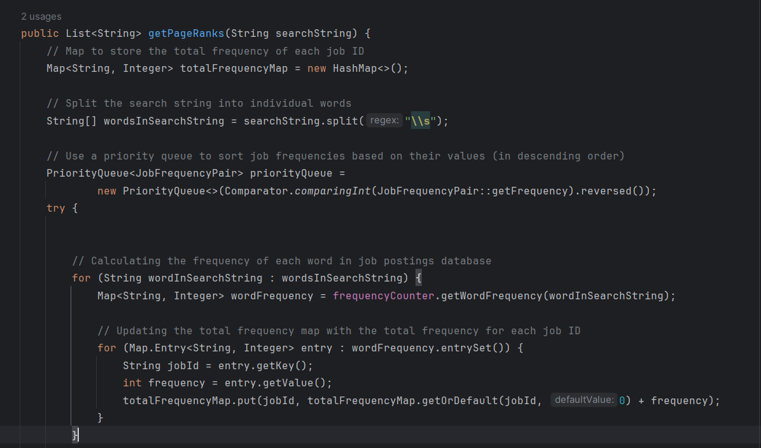

It then populates the priority queue with entries from a map (totalFrequencyMap). It catches and prints any exceptions that might occur during this process. Then, it extracts sorted job IDs from the priority queue into a list, and finally, our code returns the sorted list of job IDs.

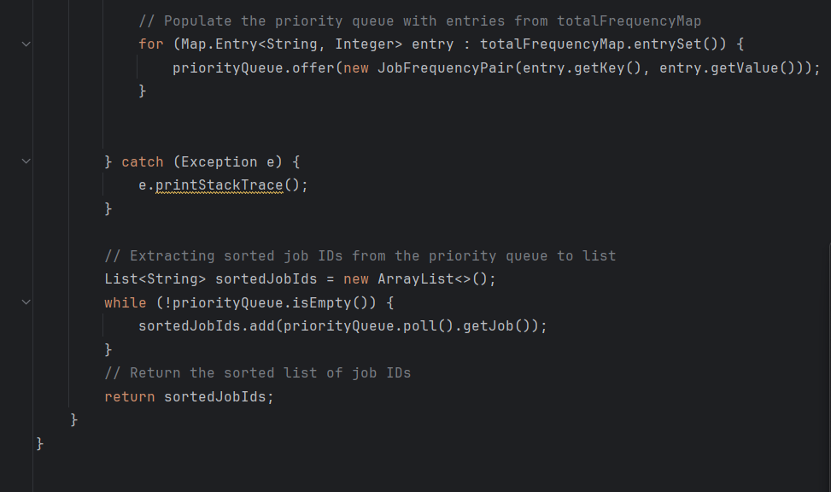

In summary, PageRanking will get each word from from user search string, and get Job ID and frequency of each word. It then performs cumulative sum and ranks the page based on the no. of occurrences.

**Reasoning for Data Structure/Algorithm:**

PriorityQueue**:** PriorityQueue provides an advantage by efficiently maintaining sorted order based on job frequencies. It is important for us to quickly identify and extract the most relevant job postings. Other data structures may require an additional sorting step. So, the priority queue is a suitable and efficient choice for our PageRanking System.

HashMap: The data structure is best when dealing with frequencies. This data structure helps us efficiently store and update the total frequency of each job ID. Its constant-time complexity for basic operations of insert, delete and search, and makes it the best choice for storing frequency information associated with specific job IDs.

**Exception Handling:**

Catches and prints a stack trace if any Exception occurs during calculating of word frequencies.

**Output:**

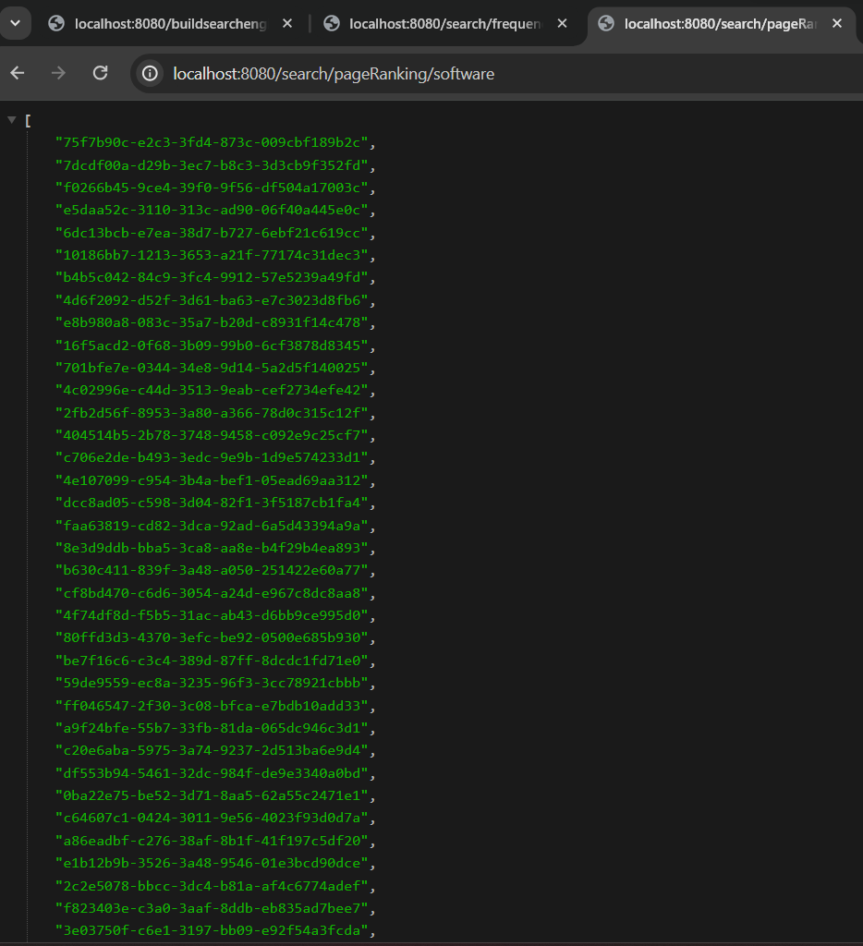

The output shows the JobIDs sorted against the search word. In our case, it is “software”. So job ID “ 75f7b90c-e2c3-3fd4-873c-009cbf189b2c“ will have a maximum no. of times software repeated in its all attributes such as Job Title, company name, and description. Thats why it ranked highest among its peers.

# 

# 7. Spell checking

**Developed by:** Kishan Modi

**Used Data Structures/Algorithms:**

* **LinkedHashSet:** Vocabulary extracted from parsed data is stored in a LinkedHashSet.
* **HashMap:** Edit Distance Scores and Jaccard Similarity Scores are maintained using a HashMap.
* **ArrayList:** Suggestions for spelling corrections are stored in an ArrayList.
* **Edit Distance:** Edit Distance is employed to determine the distance between the entered word and the vocabulary words.
* **Jaccard Similarity:** Jaccard’s Similarity computes a similarity score between 0 and 1, with a higher score indicating greater similarity to words in the vocabulary.

**File Name:** SpellCheckingService.java, JaccardSimilarity.java, EditDistance.java, Database.java, VocabularyBuilder.java

**Explanation:**

In the search engine spell checking, two algorithms, namely Edit Distance and Jaccard Similarity, are used. These algorithms are combined and their scores are normalized to enhance their effectiveness. The initial vocabulary is constructed by extracting data from the HTML parser. Leveraging this vocabulary, we calculate both edit distance and Jaccard similarity scores. The user is then presented with corrected spelling suggestions in the front end, accompanied by a "Did you mean?" prompt, alongside the display of accurate search results.

**Following are the explanations for individual functions being used for spell checking.**

**1. Build Vocabulary**

* **buildVocabulary(List<JobPosting> jobPostingList) : void**

In this section, data is extracted from parsed job listings to construct a vocabulary. Words are added to a LinkedHashSet, chosen for its ability to preserve the order of word entry. During spell-checking, greater priority is assigned to job titles and locations, which are more frequently searched by users. By placing these terms at the beginning of the vocabulary, there is an increased chance of providing correct spellings, even if other unrelated words with similar edit distance or Jaccard scores exist further down the list.

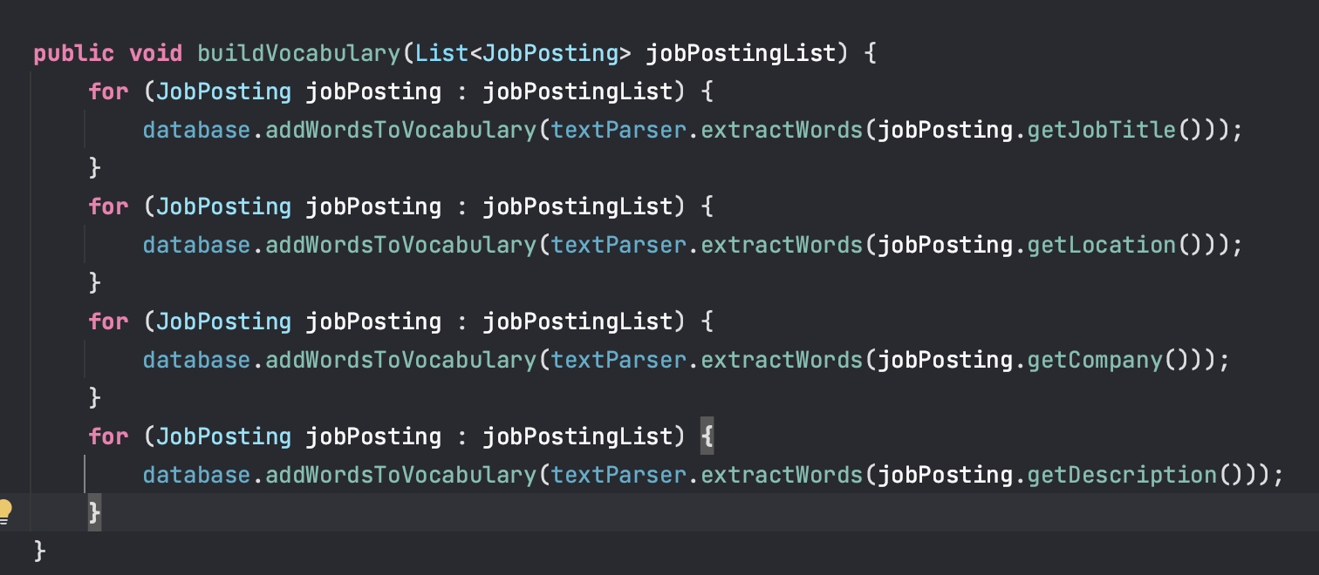

(Fig - BuildVocabulary Function - Database.java)

**2. Calculate Edit Distance**

* **calculateEditDistance(String word1, String word2) : int**

The Edit Distance algorithm compares two words, word1 and word2, by transforming word1 into word2 through three operations: inserting a character, deleting a character, or replacing a character. The function employs dynamic programming, utilizing a 2x2 matrix to store edit distances between parts of the words. It follows a bottom-up approach, starting from smaller subproblems and building up to the entire words. The algorithm continues these operations until the second word becomes identical to the first one, and the total edit distance is then returned as the result.

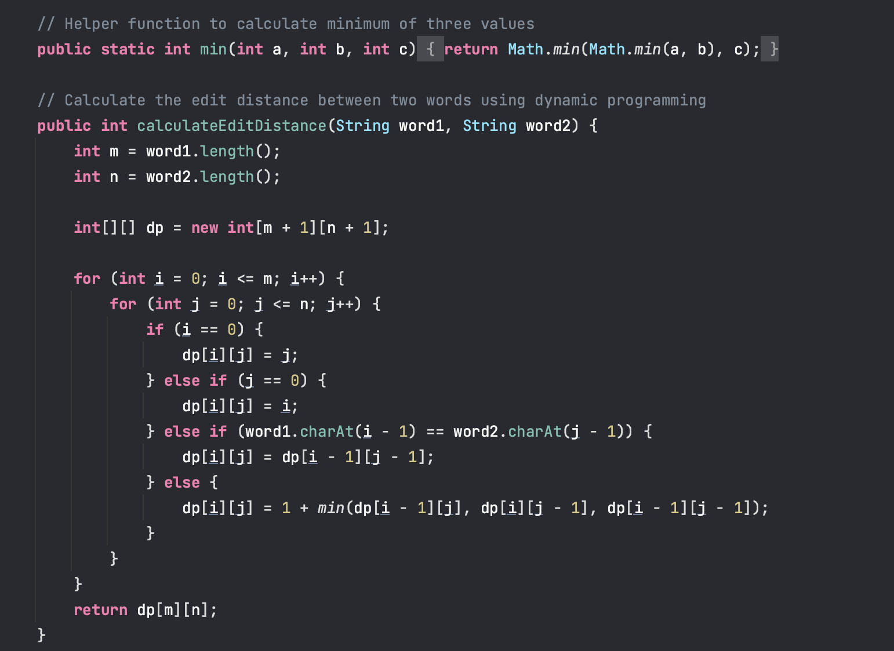

(Fig - calculateEditDistance Function - EditDistance.java)

**3. Calculate Jaccard Similarity**

* **calculateJaccardSimilarity(String word1, String word2) : Double**

Jaccard Similarity is a measure used to assess the similarity between two objects, such as strings. In this context, the Jaccard Similarity calculates the ratio of the number of characters in the intersection of two words to the number of characters in their union. The resulting score ranges between 0 and 1, with higher scores indicating greater similarity. A score of 0.7 or above is generally considered a good indicator of similarity.

In the function, the two input words are first converted into character arrays. These arrays are then added to two sets, representing the characters of each word. Subsequently, the algorithm computes the intersection and union of these sets to determine the similarity between the words. The final output is a similarity score, with values closer to 1 suggesting a higher degree of similarity between the words.

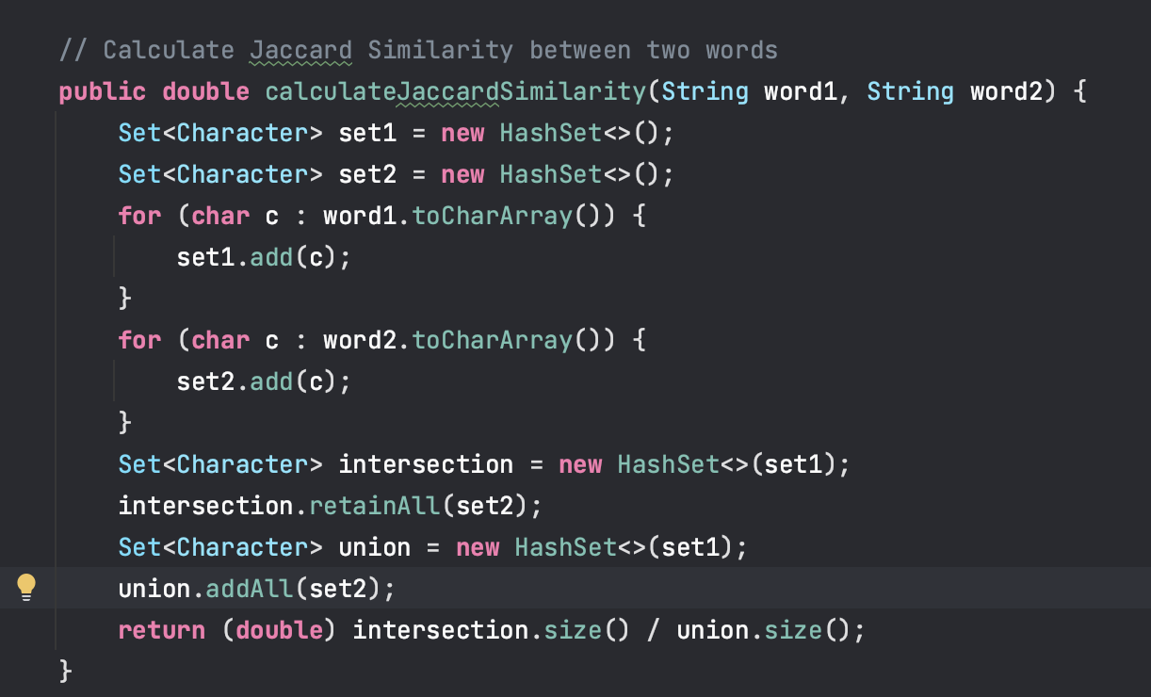

(Fig - calculateJaccardSimilarity Function - JaccardSimilarity.java)

**4. Generate Suggestions by Edit Distance**

* **generateSuggestionsByJaccard(String misspelledWord, Set<String> vocabulary, int suggestionCount) : List<String>**

In this scenario, the edit distance function is being utilized to identify similar words within a vocabulary constructed from data obtained through web scraping. The specified threshold for considering words as similar is set to an edit distance of less than 4. The function returns an ArrayList of suggested words based on this criterion.

The function takes an additional parameter, "suggestions count," which serves as the maximum limit for the number of suggestions a word can have. This count acts as a threshold for the API, determining the maximum number of suggestions that can be returned.

Internally, the function calculates edit distance scores for each word in the vocabulary and stores these scores along with the corresponding words. These scores are then used to sort the suggestions, ensuring that words with lower edit distance scores appear first in the list. The final output is a sorted list of suggested words based on their similarity to the input word, considering the specified threshold.

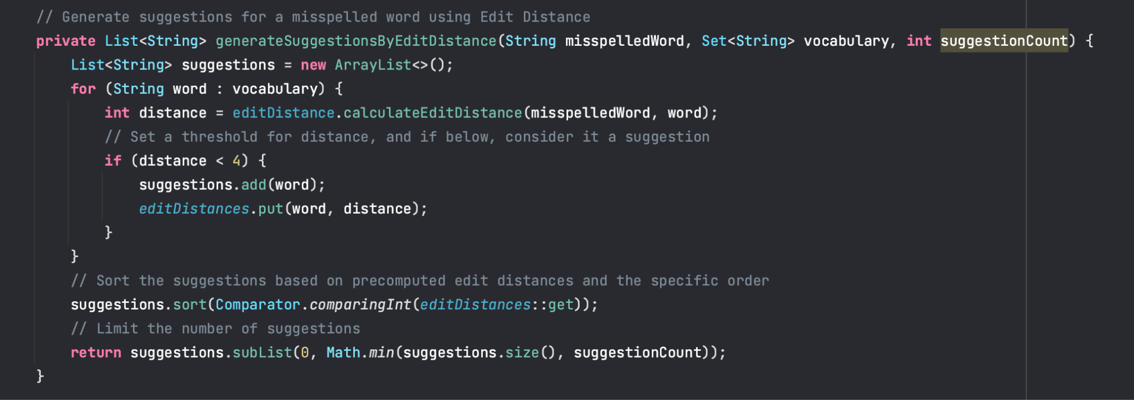

(Fig - generateSuggestionsByEditDistance Function - SpellCheckingService.java)

**5. Generate Suggestions by Jaccard’s similarity**

* **generateSuggestionsByJaccard(String misspelledWord, Set<String> vocabulary, double threshold, int suggestionCount) : Double**

In a similar fashion to the edit distance suggestion function, the Jaccard Similarity function is employed to determine the similarity score between words within a vocabulary generated from web-scraped data. The threshold for considering words as similar is determined by a specified Jaccard similarity score.

Internally, the function calculates the Jaccard similarity scores for each word in the vocabulary and includes these scores in the suggestion list. The list is then sorted based on the similarity scores, ensuring that words with higher Jaccard similarity scores are prioritized in the output. The final result is a sorted list of suggested words based on their similarity to the input word, considering the specified Jaccard similarity threshold.

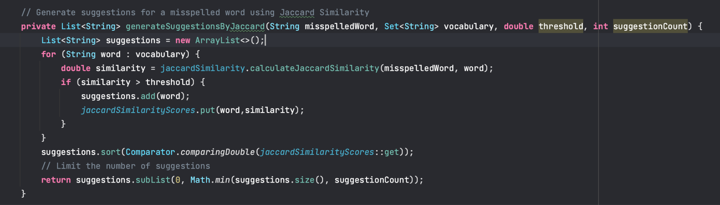

(Fig - generateSuggestionsByJaccard Function - SpellCheckingService.java)

**5. Compare both suggestions and normalize the similarity score**

* **findMostAccurateSuggestion(List<String> editDistanceSuggestions, List<String> JaccardSimilaritySuggestions, String OriginalWord): String**

Now, with suggestions from both algorithms, there might be slight variations in scores due to the different scales of Jaccard similarity (ranging from 0 to 1) and edit distance (possibly in decimal values).

After merging the suggestions, scores are checked and initially created HashMap for both EditDistanceScores and JaccardSimilarityScores, so we don’t have to calculate these scores again if they exist in the HashMap, if they aren't in the map, Edit Distance and Jaccard Similarity are calculated with the function previously created. Also, it clears out the Edit Distance Scores Map and Jaccard Similarity Scores at the at of the function scope.

To ensure consistency, the scores are normalized using the formula ‘editDistanceScore + 10 * (1 - jaccardSimilarityScore)’ for the same suggestions. This normalization process aims to provide a more accurate measure of similarity. The function returns the suggestion with the lowest normalized score, and if there are no suggestions, an empty string is returned.

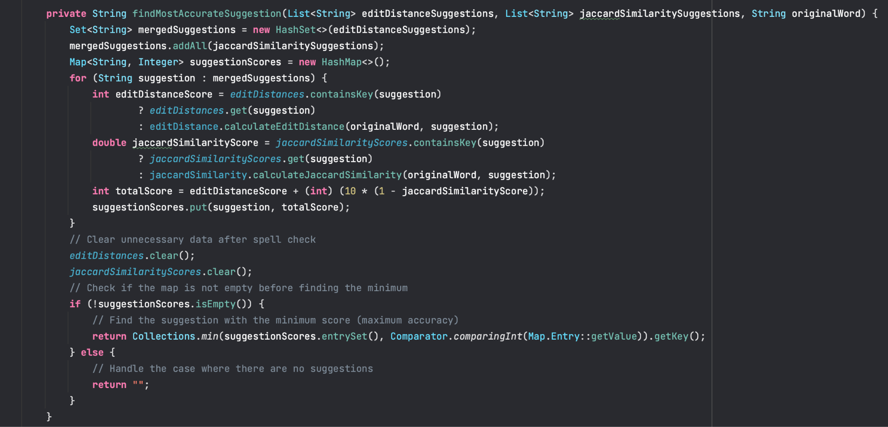

(Fig - findMostAccurateSuggestion Function - SpellCheckingService.java)

**6. Spell Check function that handles the whitespace and exception**

* **spellCheck(String userInput): String**

In the primary function of the spell checker, the initial step involves checking the entered search term. If it is either empty or contains whitespace, exceptions are raised. Word is further processed to remove any punctuation, whitespace or special characters before spell-checking to get the most accurate result.

Following this, the term is split into words, and each word is verified against the vocabulary. If a word exists in the library, it is considered correctly spelled. If a word is not found in the vocabulary, the functions **suggestionsByEditDistance** and **suggestionsByJaccardSimilarity** are invoked. The results from these functions are then used in a call to **findMostAccurateSuggestions** to obtain the final suggestion with the highest accuracy. If we don’t have any suggestion using these methods, the original processed words is returned.

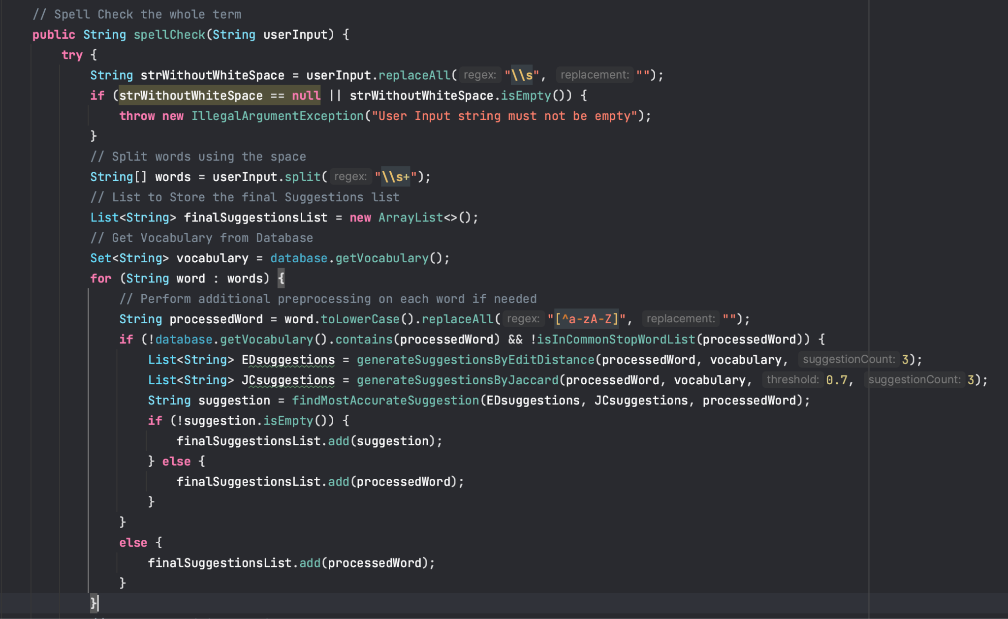

At the end of the function, the corrected words are joined and returned as strings so they can shown in the front end. In the event of an exception original word is being shown in the front end.

**Exception Handling:**

Catches and prints a stack trace if any Exception occurs during spell checking and returns the original word to the user.

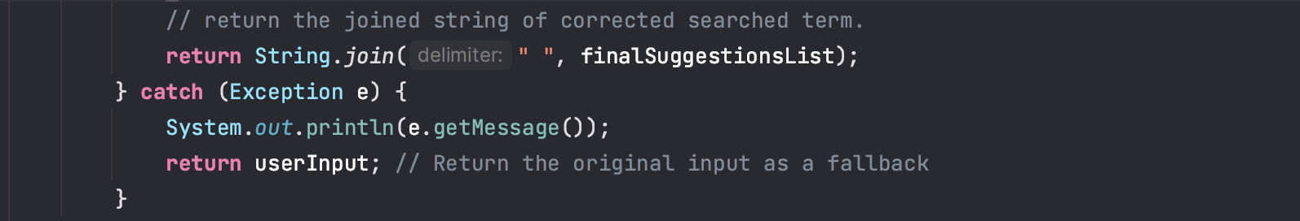

(Fig - spellCheck Function - SpellCheckingService.java)

**Output:**

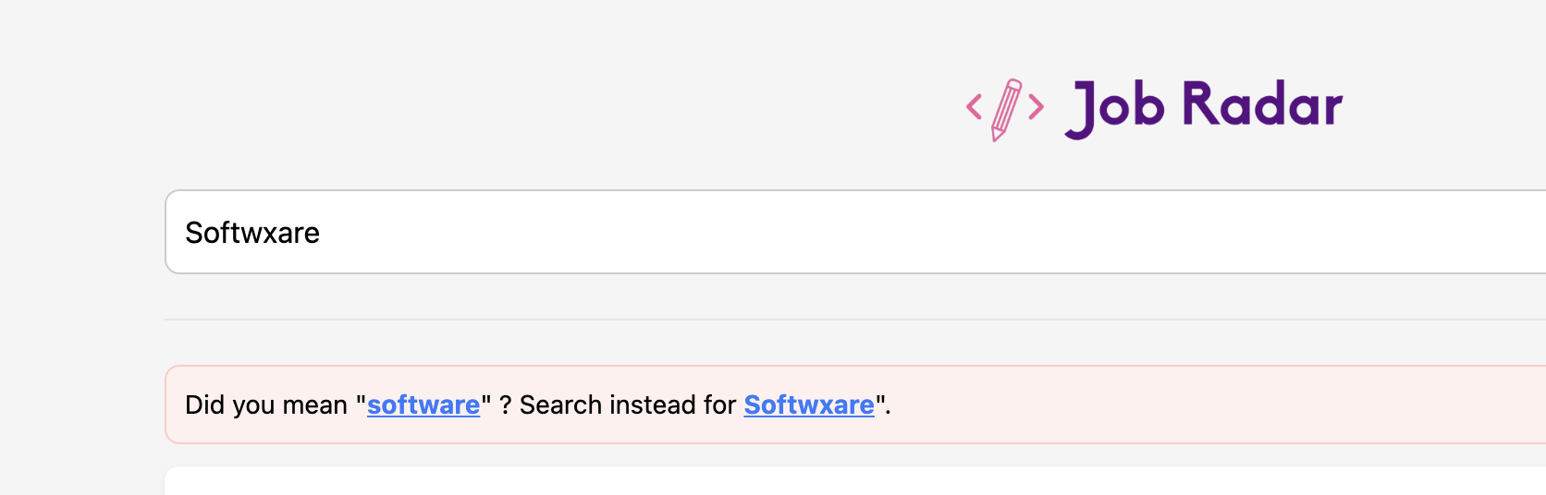

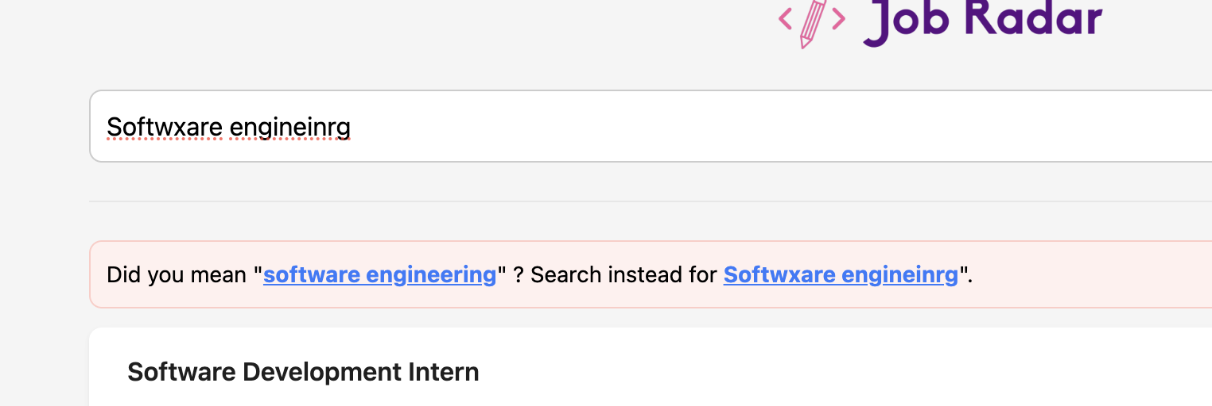

(Fig - Spell Check Output)

# 8. Word completion

**Feature**: Word Completion  
**Developed by**: Miti Tamakuwala  
**Used Data Structure/Algorithm**: Trie, Edit Distance, HashMap, ArrayList,   
**File name**: AutoComplete.java

**Explanation**:

We are inserting words into the Trie data structure and then suggesting word completions based on user input prefixes by considering a specified maximum edit distance. The suggestions are displayed as output.

**Necessary Imports:**  
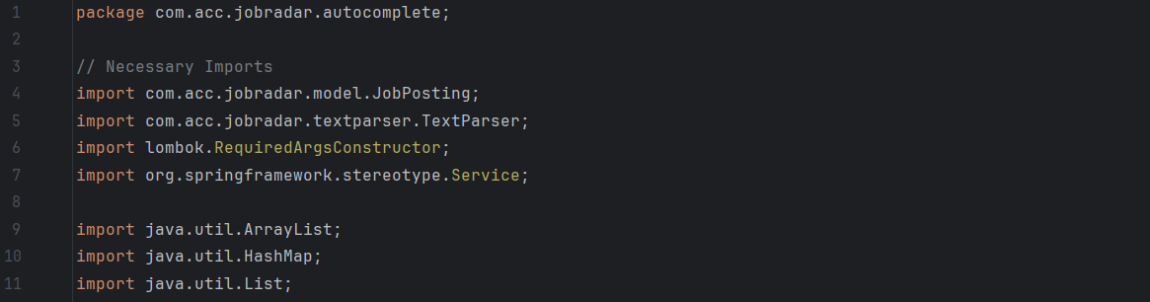

**Working:**

**AutoComplete class:** Ituses a Trie data structure which is represented by the **TrieNode** class to efficiently store and retrieve words.  
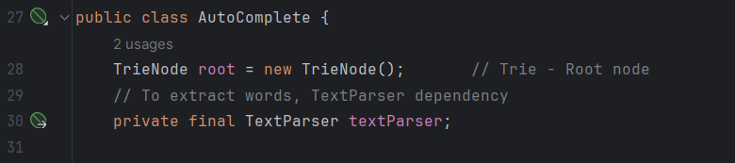

**buildAutoComplete:** This method builds and populates the Trie data structure with all the job posting information (job roles, companies, locations, and job descriptions).  
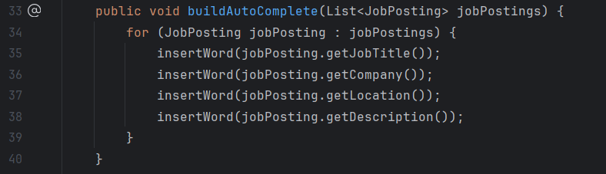

**suggestWords:** Thismethod takes a prefix as input received from the user in the search field. And then splits it into words to retrieve word suggestions considering the last word as the new prefix.

**Additional functionality**: It also supports multi-word input by considering the last word as the prefix for completion suggestions. So basically, it works like auto complete.  
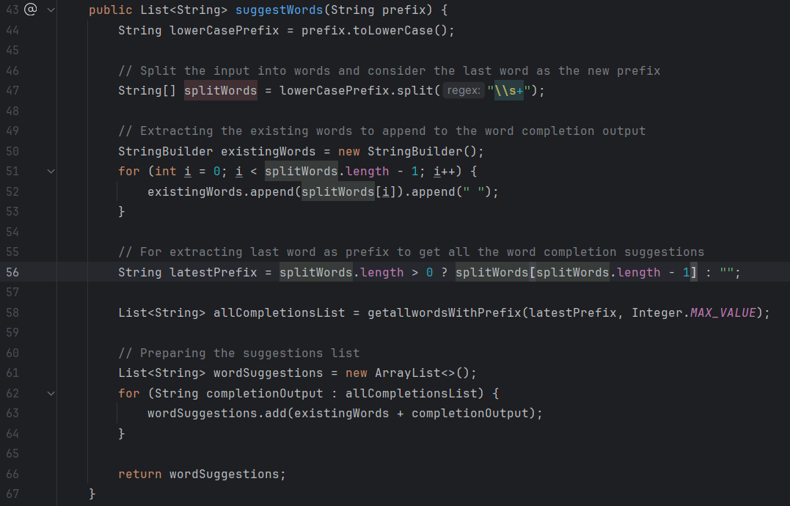

**TrieNode**: TriNode represents every node in the Trie. It contains a boolean flag (**isEndOfWord**) that indicates when a word ends and a hash map to store child nodes based on characters.

**Reasoning for Data Structure/Algorithm**

**Trie Data Structure** (efficient word retrieval):   
Efficiently represents a collection of words and allows quick word insertion and retrieval. It is specifically useful for word completion scenarios.

**Edit Distance:**   
The edit distance mechanism allows to find words in the Trie that are similar to the given prefix within a specified number of allowable changes. This feature is useful for providing flexible and forgiving suggestions in cases where the user input may have slight variations.

**HashMap** (Quick Access):   
A HashMap is used to store children nodes of each Trie node, providing quick access during word insertion and retrieval.

**Output**:

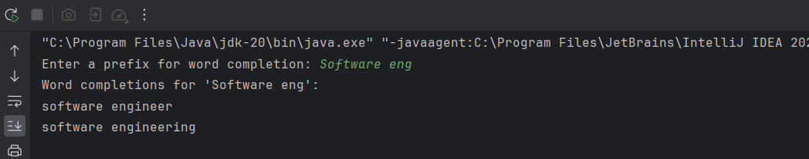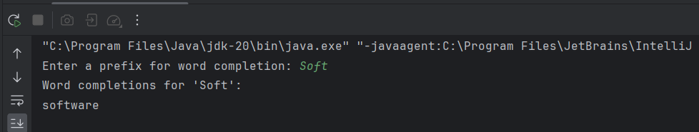

Multi-word input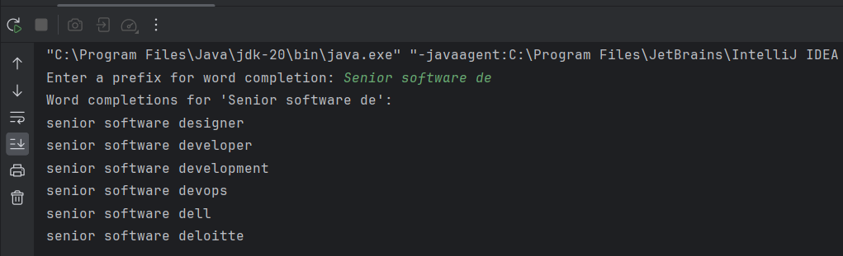

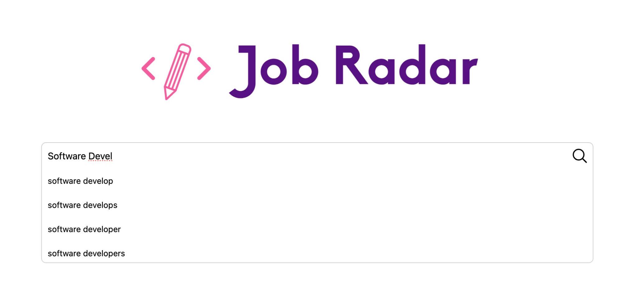

# 9. Search frequency

**Developed by:** Kishan Modi

**Used Data Structures/Algorithms:**

* **Priority Queue - Max Heap:** As we only need the top 10 Trending search terms, the best option would be to use the max heap to store only the top 10 trending terms which can be retrieved.
* HashMap: HashMap is used for storing the frequency of words searched by the user.
* ArrayList: ArrayList is used to return the top 10 trending terms to the front end.

**File Name:** SearchFrequencyTracker.java, Database.java, SearchFrequency.java

**Record Search**

* **recordSearch(String userInput): void**

The Record Search Function is designed to take user input as a parameter, and it is typically called after the spell check API returns an accurately spelled result in the front end. The function begins by checking for whitespace and handling any exceptions that may arise. Following this, the terms are split into words, and any punctuation is removed. The terms are then converted to lowercase. Subsequently, common English stop words are removed to prevent them from being stored in the frequency map.

The entire term is stored in the database using the addSearchTermToFrequency function. Additionally, each word's list is passed as a parameter to the addSearchedWordsToWordFrequencyMap function, which then stores this information in the database. This process ensures that the frequency map is updated with the user's search terms and their corresponding word frequencies.

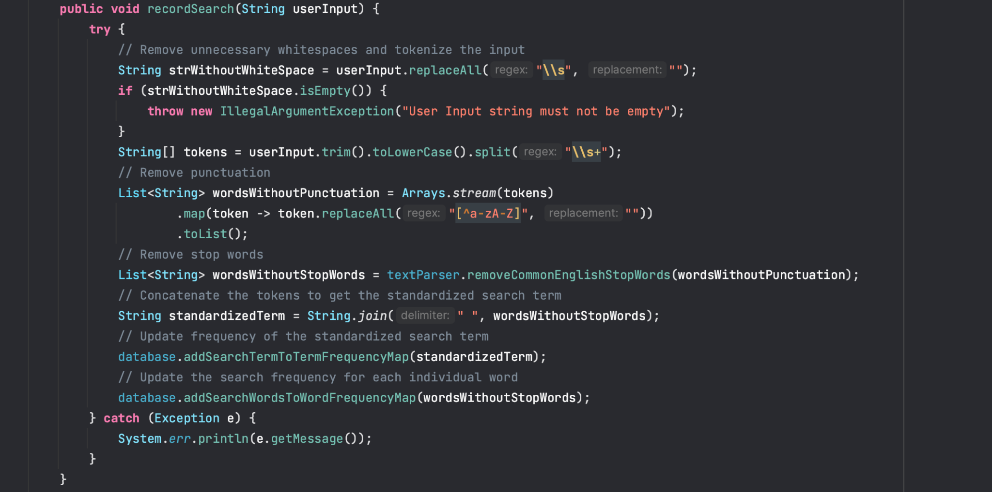

**Add Searched Words into the Frequency Map**

* **addSearchedWordToWordFrequencyMap(List<String> words): void**

In this function, we're recording every searched word on a map and keeping track of how frequently each word is searched.

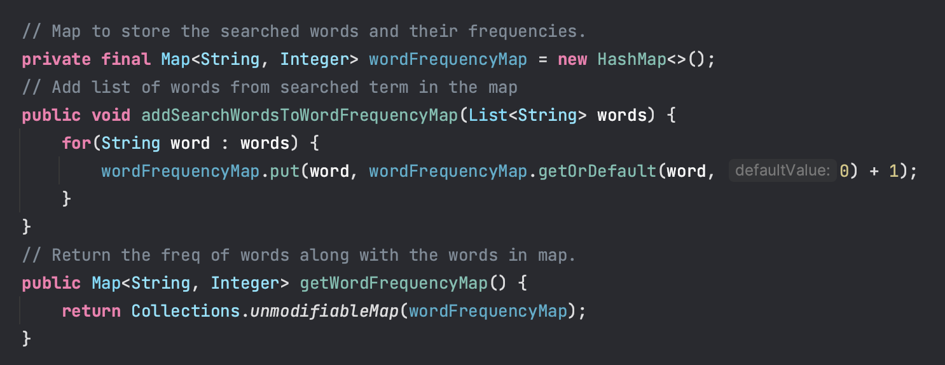

**Add Search Term into Top Trending Terms**

* **addSearchTermToTermFrequency(String searchTerm): void**

In this function, the entire search term is stored in a priority queue, implemented as a max heap. The choice of a max heap is based on the decision to retrieve only the top 10 trending terms efficiently, as accessing the top K elements in a max heap takes O(K) time. The process involves first increasing the term frequency in the map. Subsequently, the max heap is cleared, which was initially created using a priority queue with a comparator to maintain the max heap order. Finally, the updated frequency words are added back into the max heap. This approach allows for efficient tracking and retrieval of the most frequently searched terms.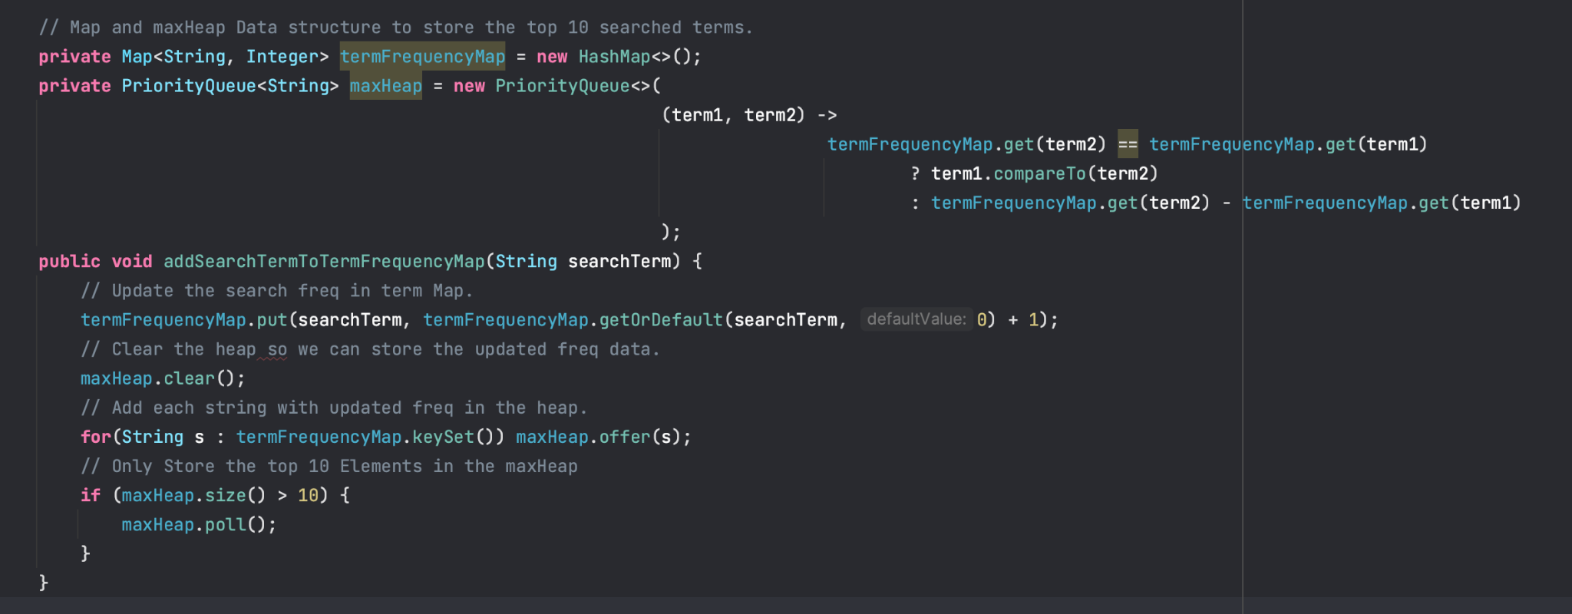

**Exception Handling:**

Catches and prints a stack trace if any Exception occurs while adding words in the search frequency map.

**Output:**

**Top Trending Search Terms:**



**Trending words with Search Frequency:**



# 10. Finding patterns using Regular Expressions

Search Query Data Validation using Regex

**Developed by:** Meet Patel

**File Name:** SearchQueryValidator.java

1. Method is ‘JustSymbolOrNumbers’
   * The method effectively checks whether a given string comprises only symbols or numbers.
   * The use of regular expressions is appropriate for this purpose.
   * Consider using String.isEmpty() instead of trim().isEmpty() for clarity and consistency.

public static boolean isJustSymbolOrNumbers(String searchQuery) {

if (searchQuery == null || searchQuery.trim().isEmpty()) {

return false;

}

Pattern pattern = Pattern.*compile*("^[^a-zA-Z-\\s]+$");

Matcher matcher = pattern.matcher(searchQuery);

return matcher.matches();

}

1. Method is ‘JustCharactersWithNumbers’
   * The method validates that a string contains only alphanumeric characters and spaces.
   * The regular expression and logic are sound for this type of validation.
   * public static boolean isJustCharactersWithNumbers(String searchQuery) {
   * if (searchQuery == null || searchQuery.trim().isEmpty()) {
   * return false;
   * }
   * Pattern pattern = Pattern.*compile*("^[a-zA-Z0-9-,\\s]+$");
   * Matcher matcher = pattern.matcher(searchQuery);
   * return matcher.matches();
   * }
2. Method ‘containsSqlKeywords’
   * The method checks if the input string contains SQL keywords and associated clauses.
   * The use of a case-insensitive pattern and word boundaries is appropriate for robust matching.

public static boolean containsSqlKeywords(String input) {

// Case-insensitive pattern for identifying common SQL keywords and clauses

String sqlPattern = "\\b(?:SELECT|INSERT|UPDATE|DELETE|CREATE|ALTER|DROP)\\b.*(FROM|INTO|SET|TABLE|DATABASE)\\b.*";

// Case-insensitive matching

Pattern pattern = Pattern.*compile*(sqlPattern, Pattern.*CASE_INSENSITIVE*);

Matcher matcher = pattern.matcher(input);

return matcher.matches();

}

1. Method validateString
   * This method combines the previous validations to ensure the input string adheres to the specified criteria.
   * The logic appears to be correct, but consider adding comments for better readability and understanding.

public static boolean validateString(String input){

if(!*isJustSymbolOrNumbers*(input) && *isJustCharactersWithNumbers*(input)){

if(*containsSqlKeywords*(input)){

return false;

}

return true;

}

return false;

}

# The Final Output is Shown in the User Interface:

  
Search Term - Marketing Coop

# 

Search Term - Software Developer Intern

# 

Result -1 Marketing Co-op



Result -1 Software Development Intern

# Additional Features Developed

**Cron Job**

**Developed by:** Meet Patel

**File Name:** MyScheduledTasks.java

Cron job to fetch data from websites

The `crawlTask` method is a scheduled task that, at midnight daily, logs "Cron Job Started" and sends an HTTP GET request to "http://localhost:8080/crawl" using a `RestTemplate`.

@Scheduled(cron = "0 0 0 * * ?")

public void crawlTask() {

System.*out*.println("Cron Job Started");

RestTemplate restTemplate = new RestTemplate();

restTemplate.getForObject(crawlEndpointUrl, String.class);

}

# References:

1. J. Hedley, “jsoup: Java HTML parser, built for HTML editing, cleaning, scraping, and XSS safety,” *Jsoup: Java HTML Parser*. <https://jsoup.org/>
2. GeeksforGeeks, “Introduction to Trie Data structure and algorithm tutorials,” *GeeksforGeeks*, May 08, 2023. <https://www.geeksforgeeks.org/introduction-to-trie-data-structure-and-algorithm-tutorials/>
3. GeeksforGeeks, “Auto complete feature using Trie,” *GeeksforGeeks*, Feb. 20, 2023. <https://www.geeksforgeeks.org/auto-complete-feature-using-trie/>
4. “Java HashMap.” https://www.w3schools.com/java/java_hashmap.asp
5. Wikipedia contributors, “Edit distance,” *Wikipedia*, Sep. 12, 2023. <https://en.wikipedia.org/wiki/Edit_distance>
6. Wikipedia contributors, “Jaccard index,” *Wikipedia*, Dec. 03, 2023. <https://en.wikipedia.org/wiki/Jaccard_index>
7. Baeldung, & Baeldung. (2023, May 6). A Guide to Java Regular Expressions API | Baeldung. Baeldung. <https://www.baeldung.com/regular-expressions-java>
8. Scheduling tasks. (n.d.). Getting Started | Scheduling Tasks. <https://spring.io/guides/gs/scheduling-tasks/>
9. W. Xing and A. Ghorbani, “Weighted pagerank algorithm,” *Proceedings. Second Annual Conference on Communication Networks and Services Research, 2004.*, 2004. doi:10.1109/dnsr.2004.1344743